LAB 1

CMPE 273 – Enterprise Distributed Systems

Prince Jacob Chandy (010807225)

**I. Introduction** (Goals and purpose of your system)

This assignment covers developing REST services using Node.js (Express JS), HTML5 and Angular JS. MySQL service is used at the server side as database.

**Calculator:** A calculator web application is developed which takes the operand values from the client side and sends to server, which then validates and performs the respective operation (addition, subtraction, multiplication, division) and pushes back the result to client, which will be provided to the user.

**eBay Marketplace Application:** Mock eBay web application is developed which replicates the actual eBay application. The developed application offers the following services:

login page: provides existing user with the option to sign in and new users with the option to register

home page: where user can view the advertisings posted by other users and initiate to buy or bid a product of his/her liking

profile page: where user can view and update his profile information and create new advertisements (normal selling or bidding)

profile page includes other important information such as sale history, purchase history and bid history.

shopping cart page: which displays the items added by the user

checkout page: which provides user option to add/update payment/credit card information and shipping address.

user can confirm buying of items in his shopping cart via checkout option

connection pooling for MySQL connections

client-sessions for session management

validations for all inputs provided by the user

**II. System Design**

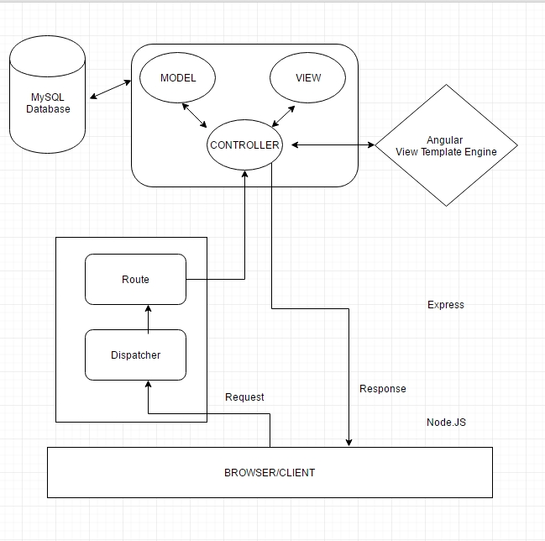

The view (HTML5) is controlled by AngularJS through Express Controller

Server side services are implemented by Node.JS

Server establishes connection via a connection pool and talks to MySQL database module

Calculator

A calculator web application is developed which takes the operand values from the client side and sends to server, which then validates and performs the respective operation (addition, subtraction, multiplication, division) and pushes back the result to client, which will be provided to the user. Database was not used for this application.

eBay Marketplace Application

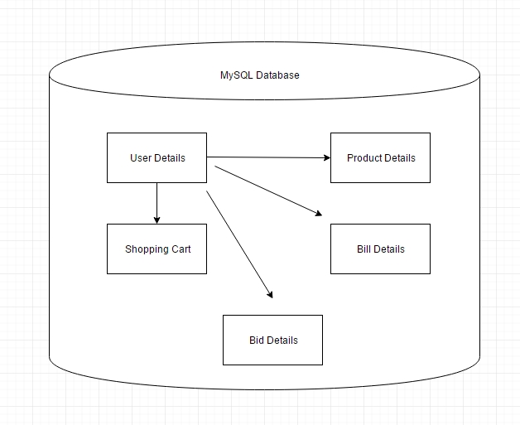

Database design for eBay application

**III. RESULTS**

Part 1 – Calculator

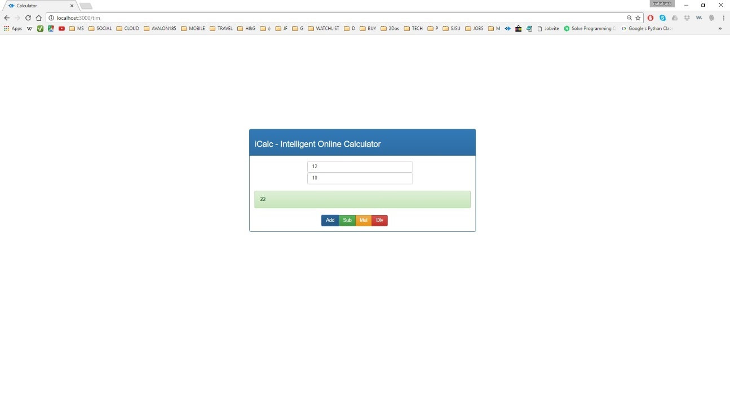

Image description: Integer Addition

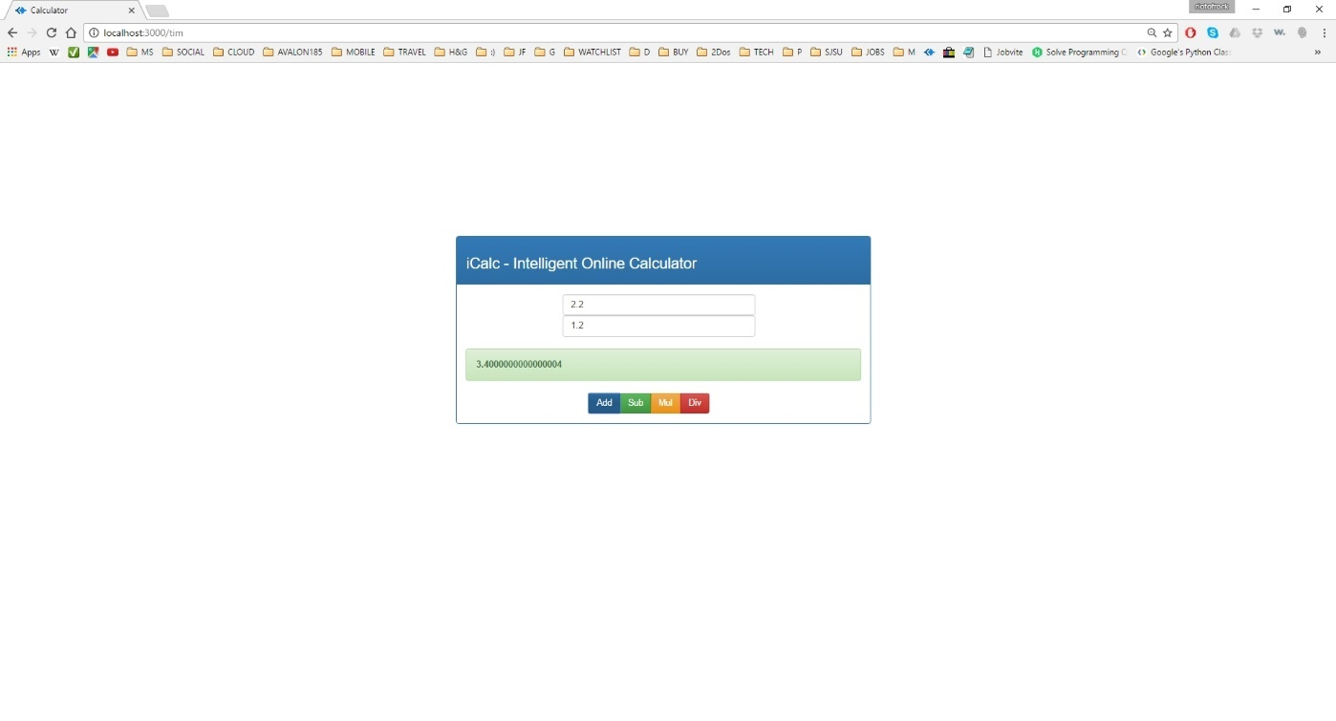

Image description: Floating point Addition

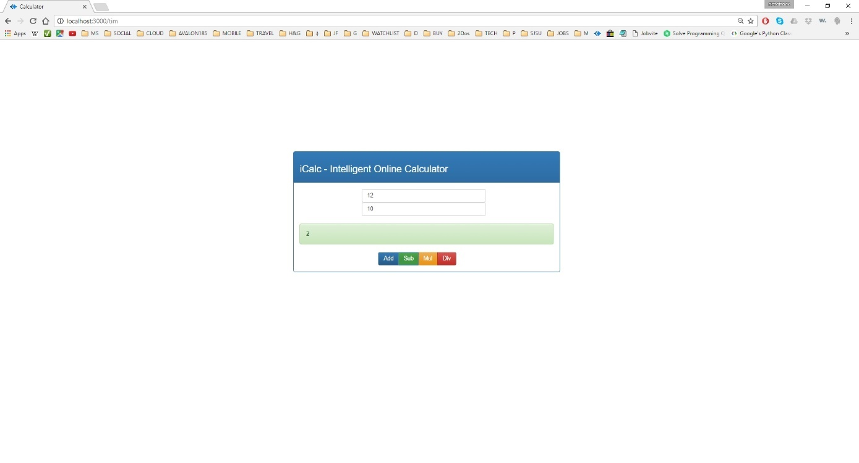

Image description: Integer Subtraction

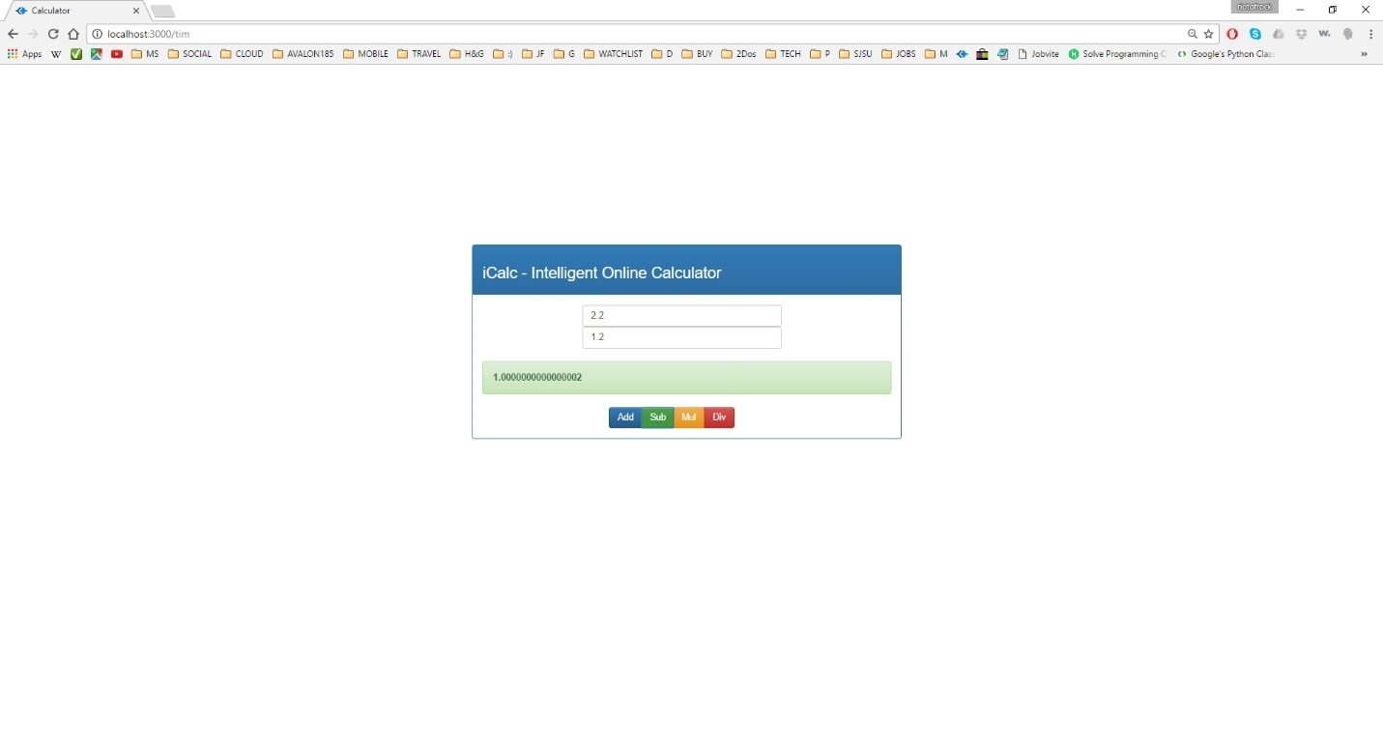

Image description: Floating point Subtraction

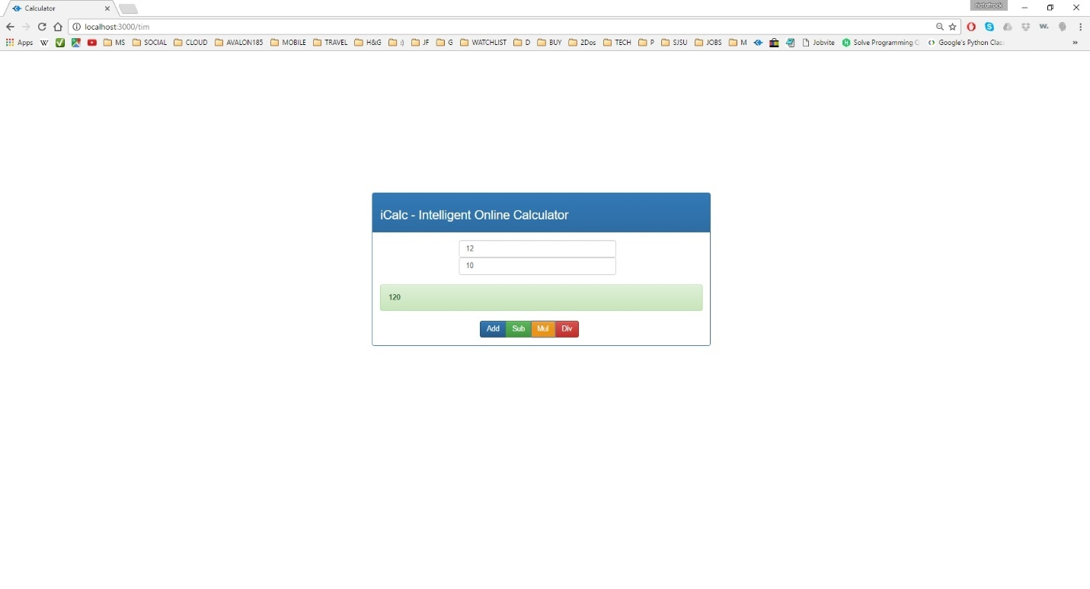

Image description: Integer Multiplication

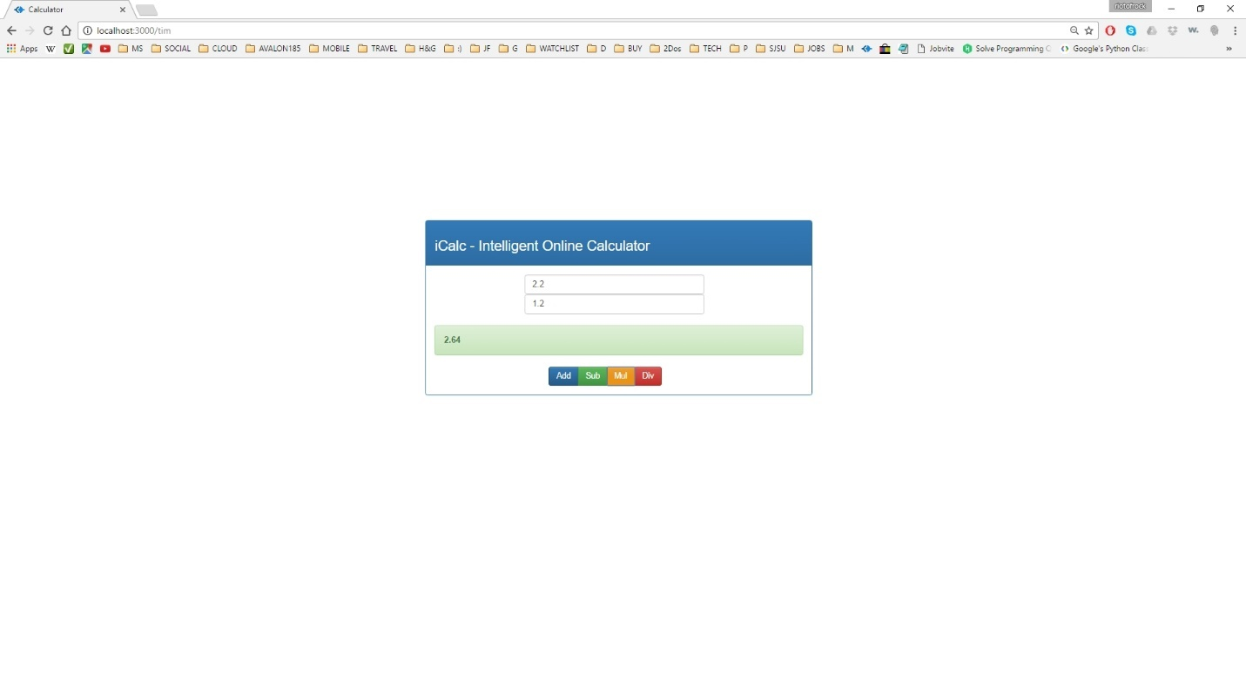

Image description: Floating point Multiplication

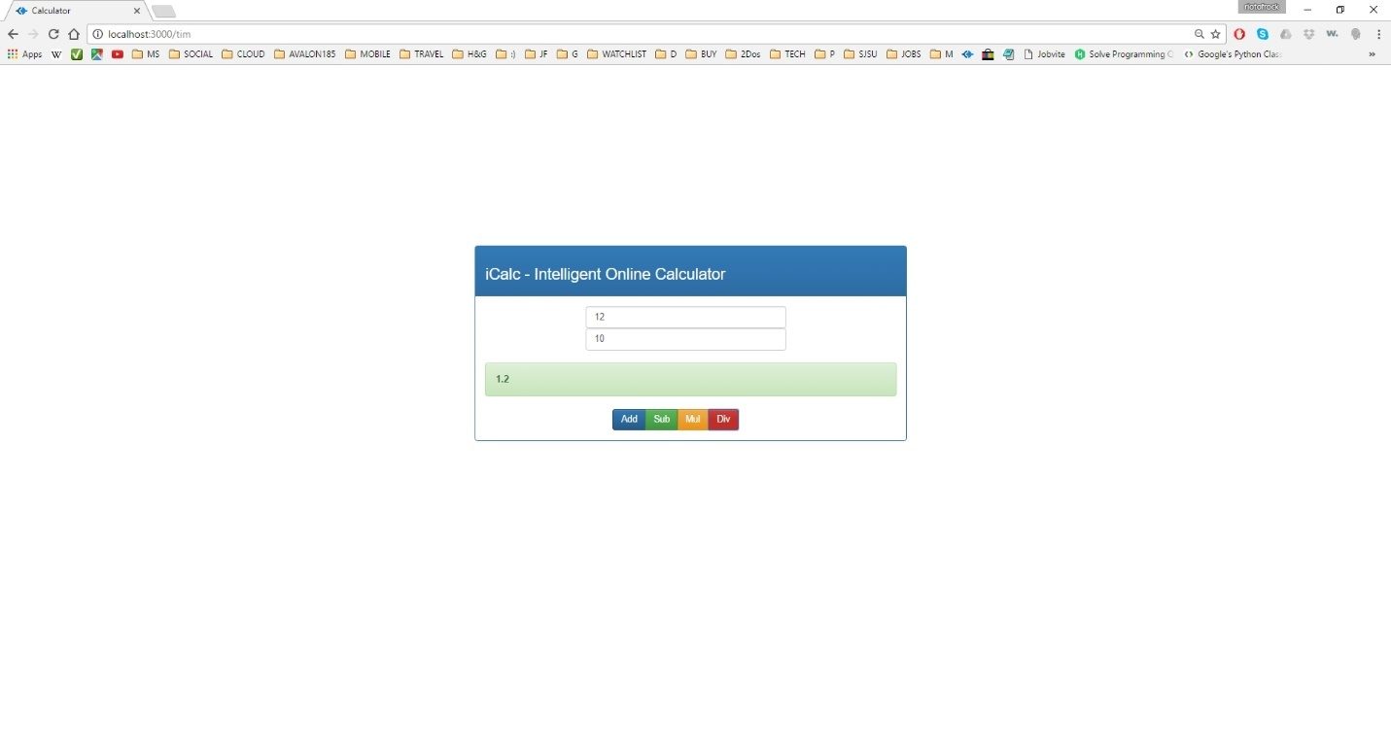

Image description: Integer Division

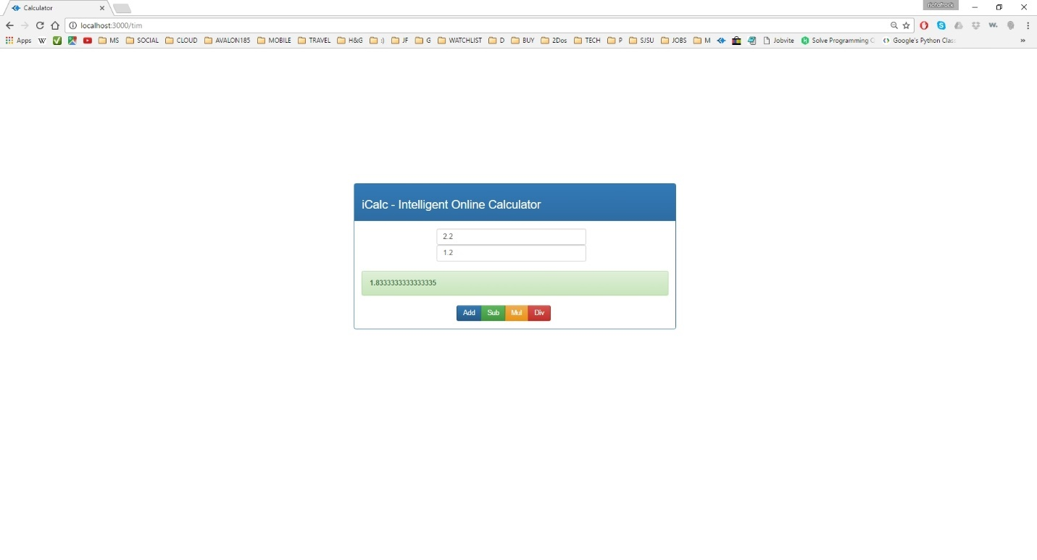

Image description: Floating point Division

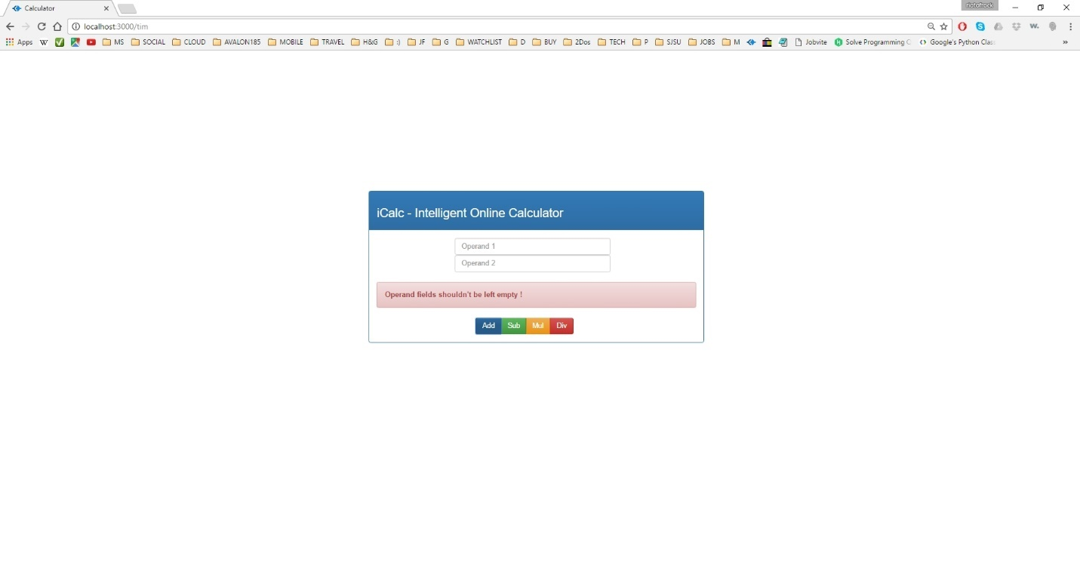

Image description: Error Scenario – Empty operand fields

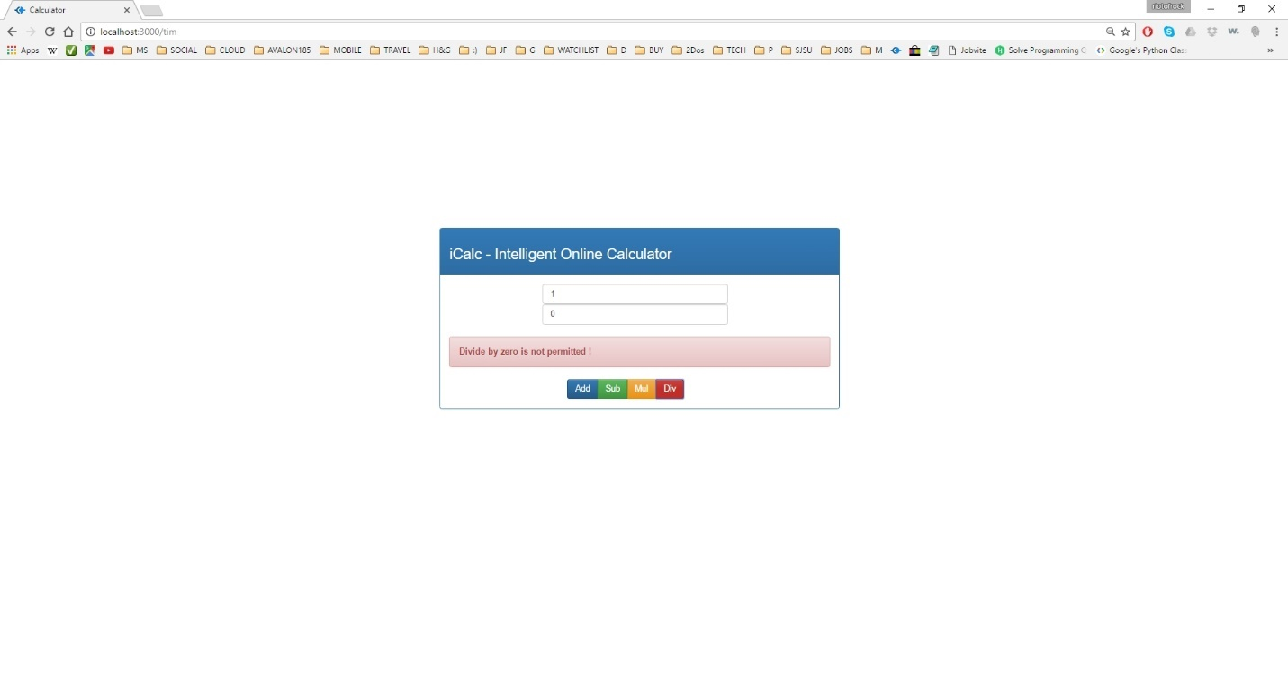

Image description: Error Scenario – Divide by zero

Part 2 – eBay Application

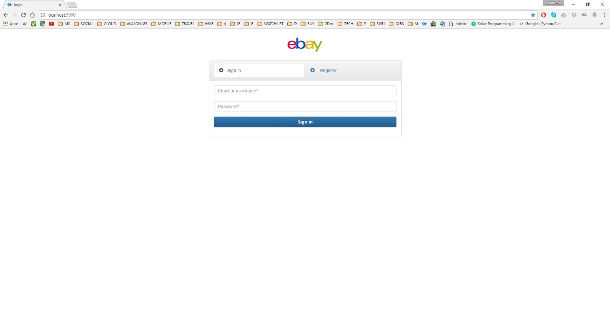

Image description: login page (sign in options)

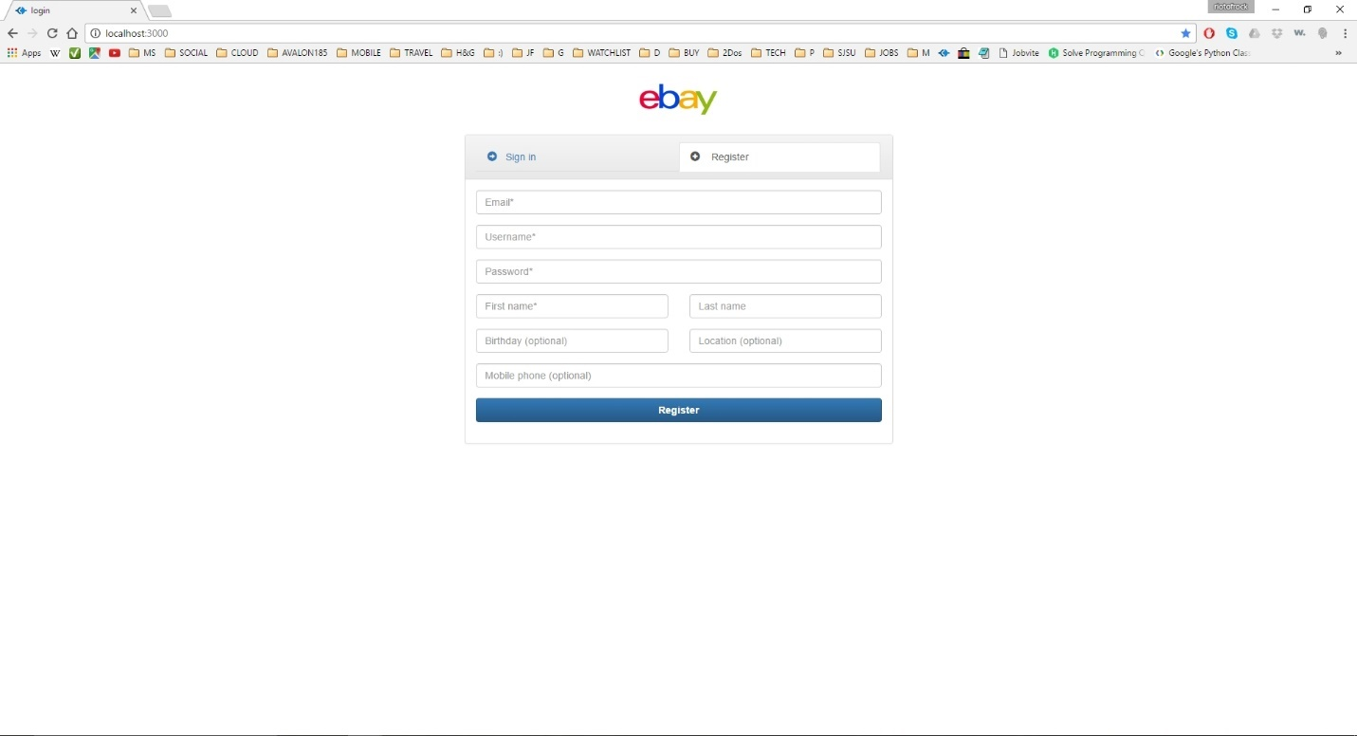

Image description: login page (sign up/register options)

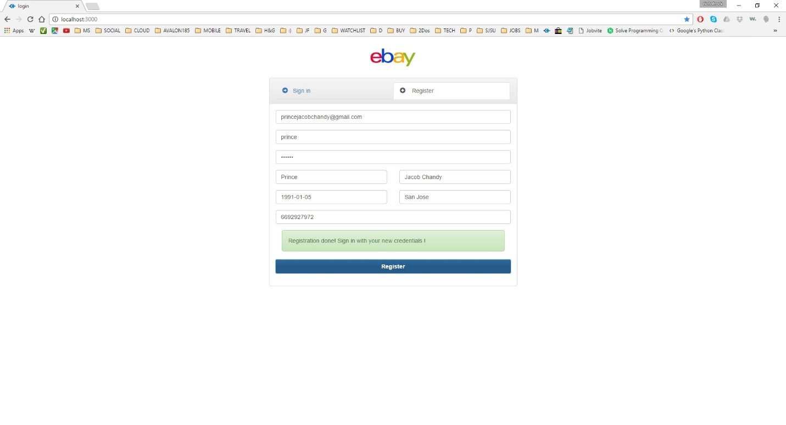

**Image description:** user registration success

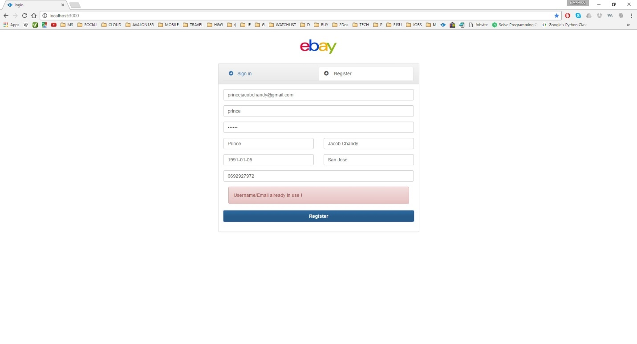

**Image description:** user registration error – username/email already in use

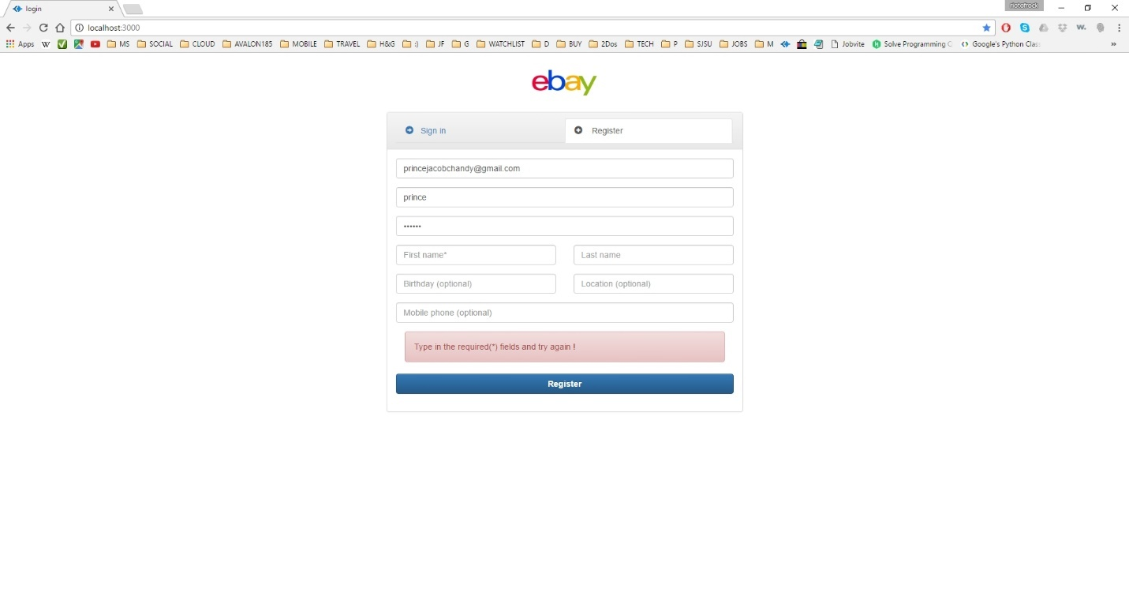

**Image description:** user registration error – required fields should be filled (required fields are marked by *)

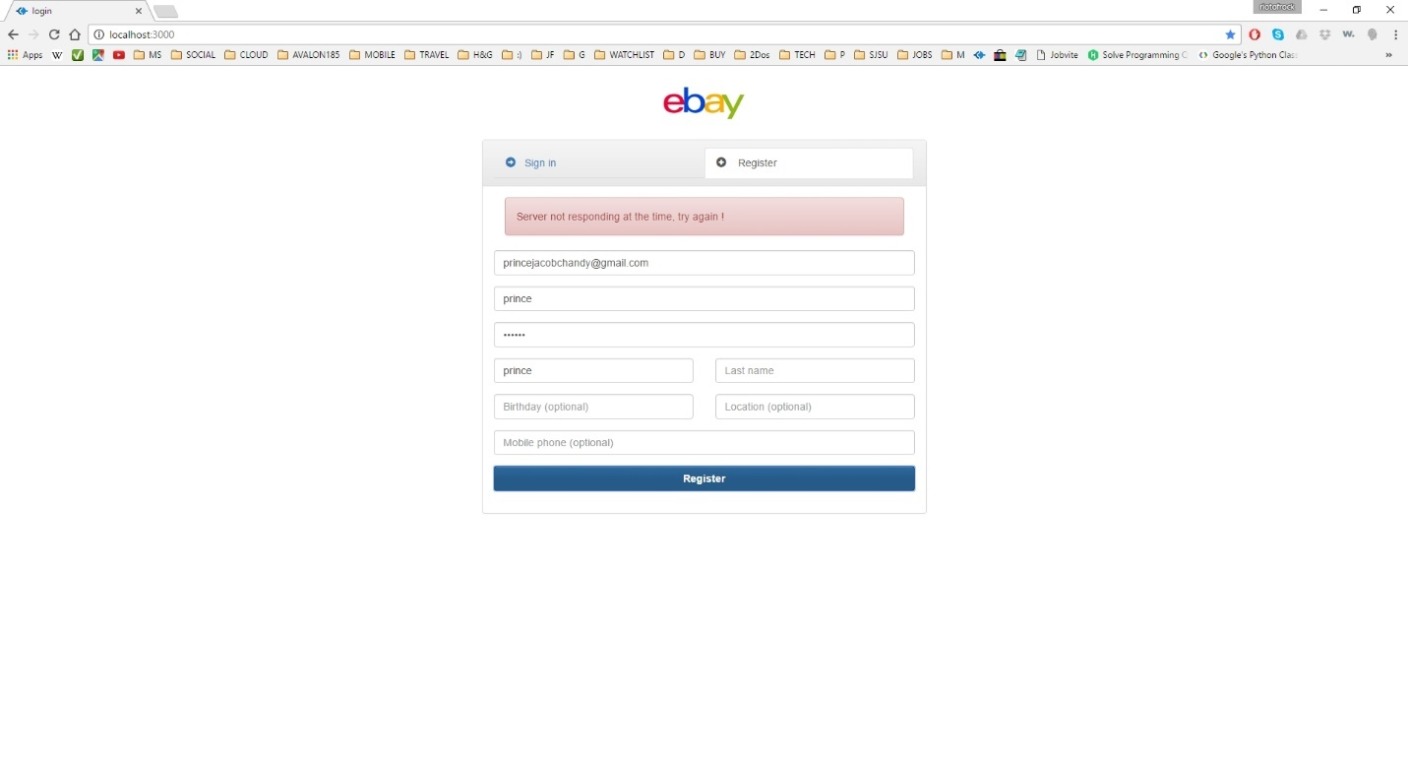

**Image description:** user registration error – server is not responding

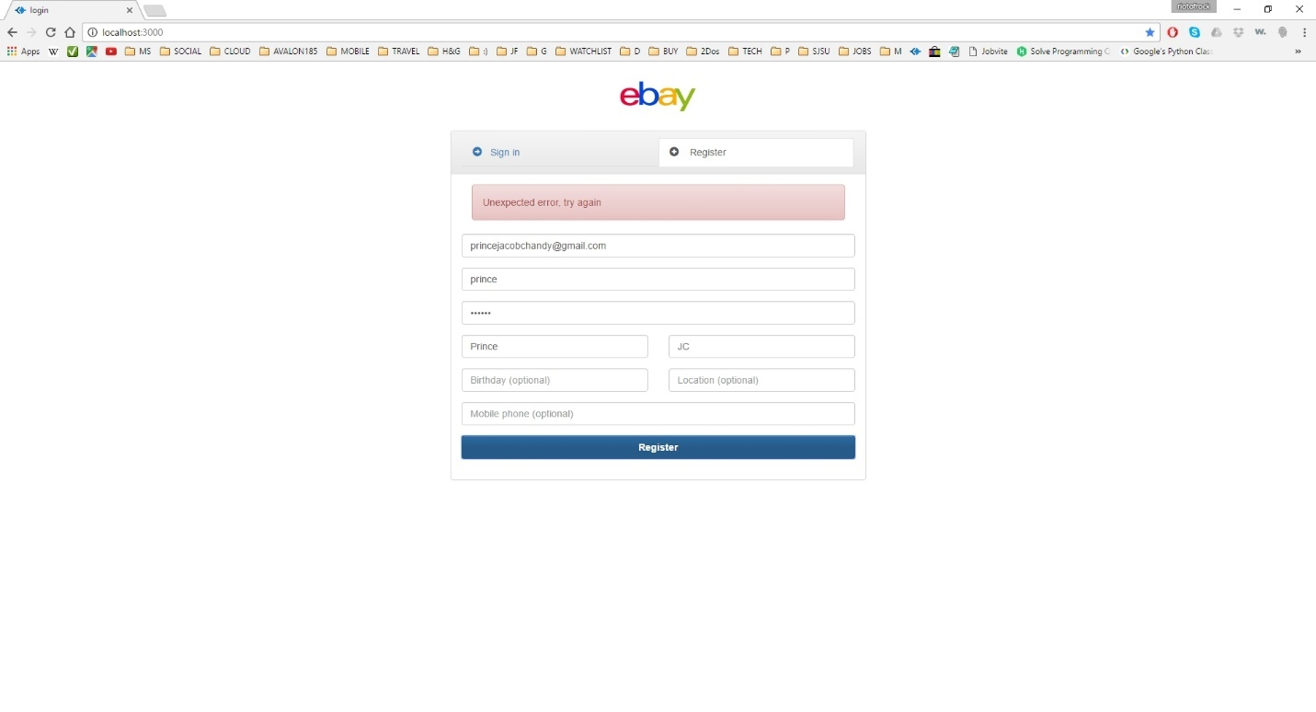

**Image description:** user registration error – in case of any other error during registration

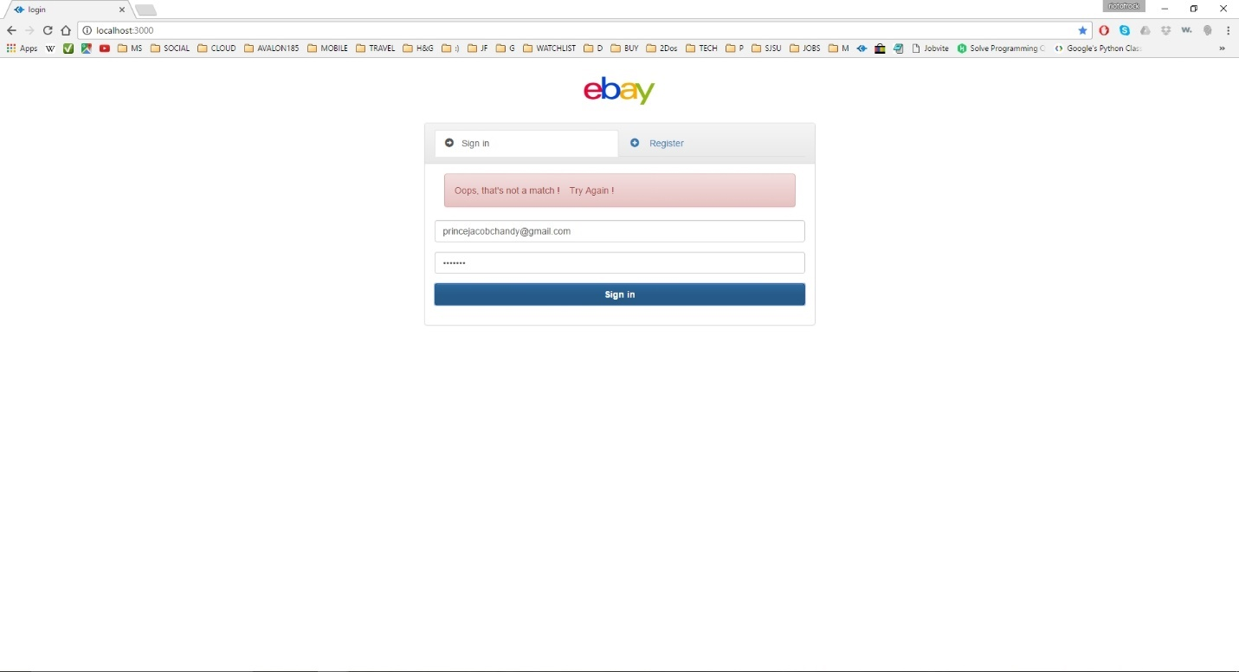

**Image description:** user login error – username and password is not matching (or not found in database)

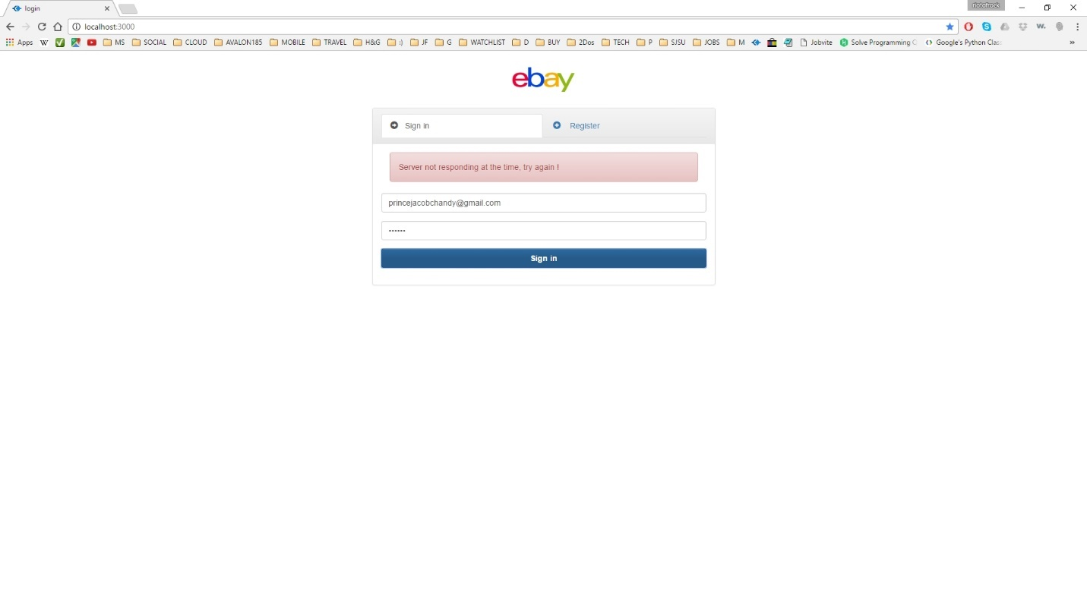

**Image description:** user login error – server is not responding/server down

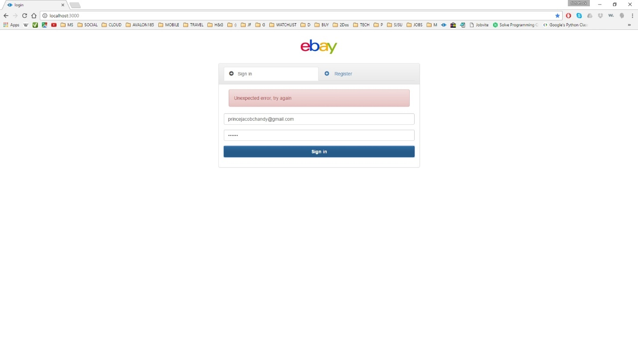

**Image description:** user login error – in case of any other error while signing in

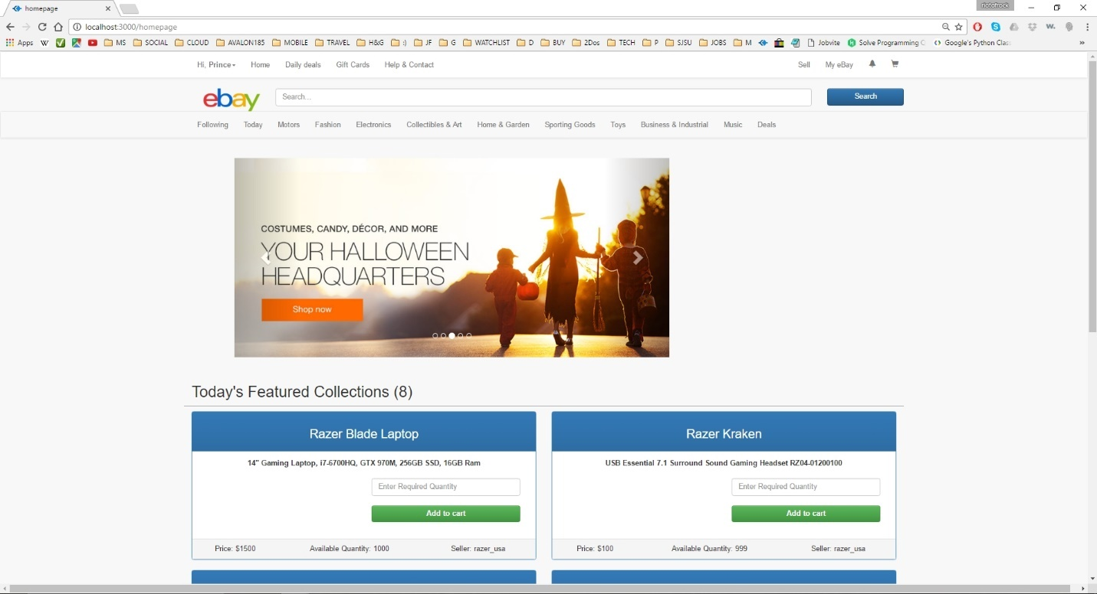

**Image description:** home page - for first time login

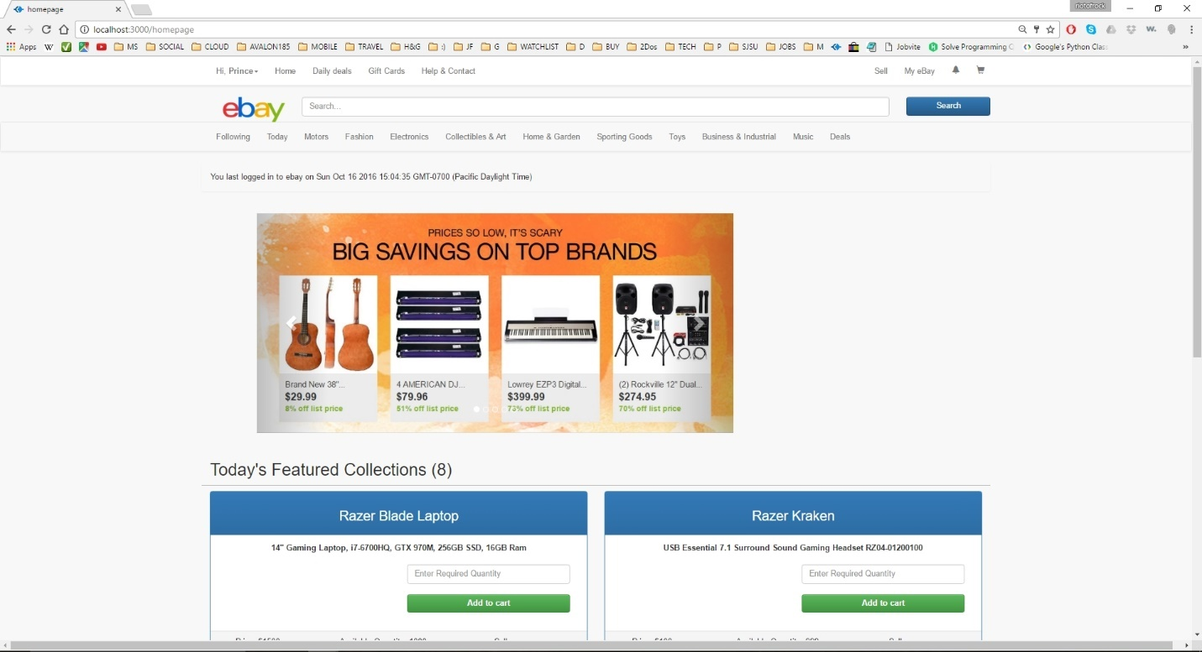

**Image description:** home page - for successive login (with last time logged in information)

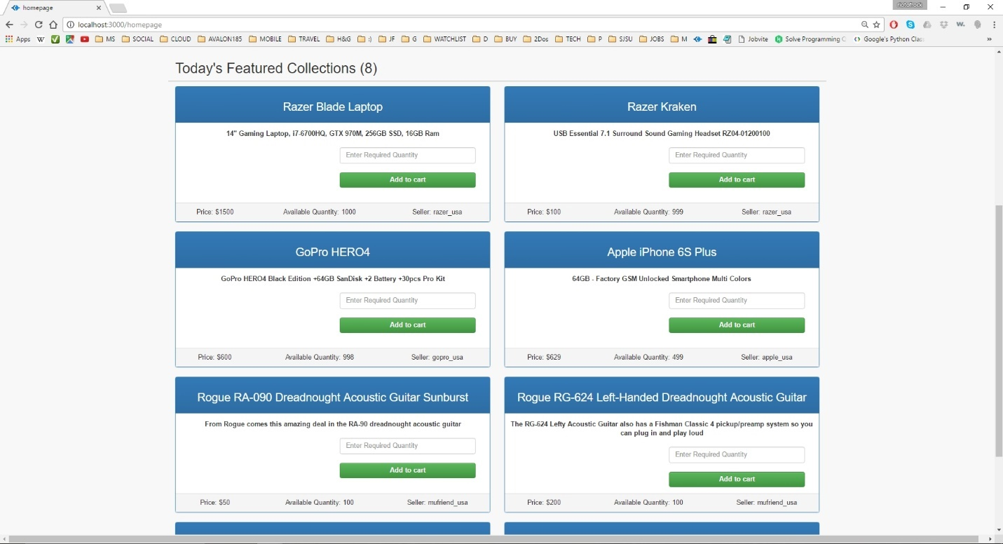

**Image description:** home page – advertisements posted by other users are listed (1); products sold out (available quantity=0) and products whose bid end time is over won’t be listed

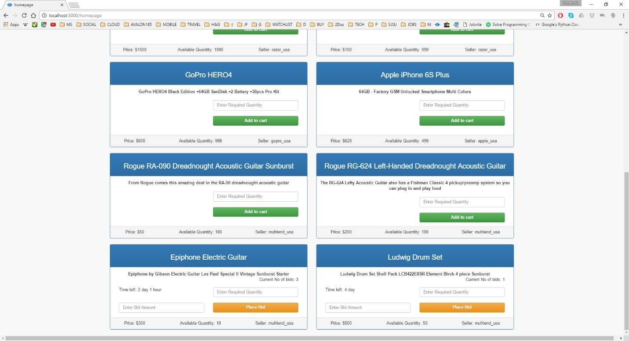

**Image description:** home page – advertisements posted by other users are listed (2); products sold out (available quantity=0) and products whose bid end time is over won’t be listed

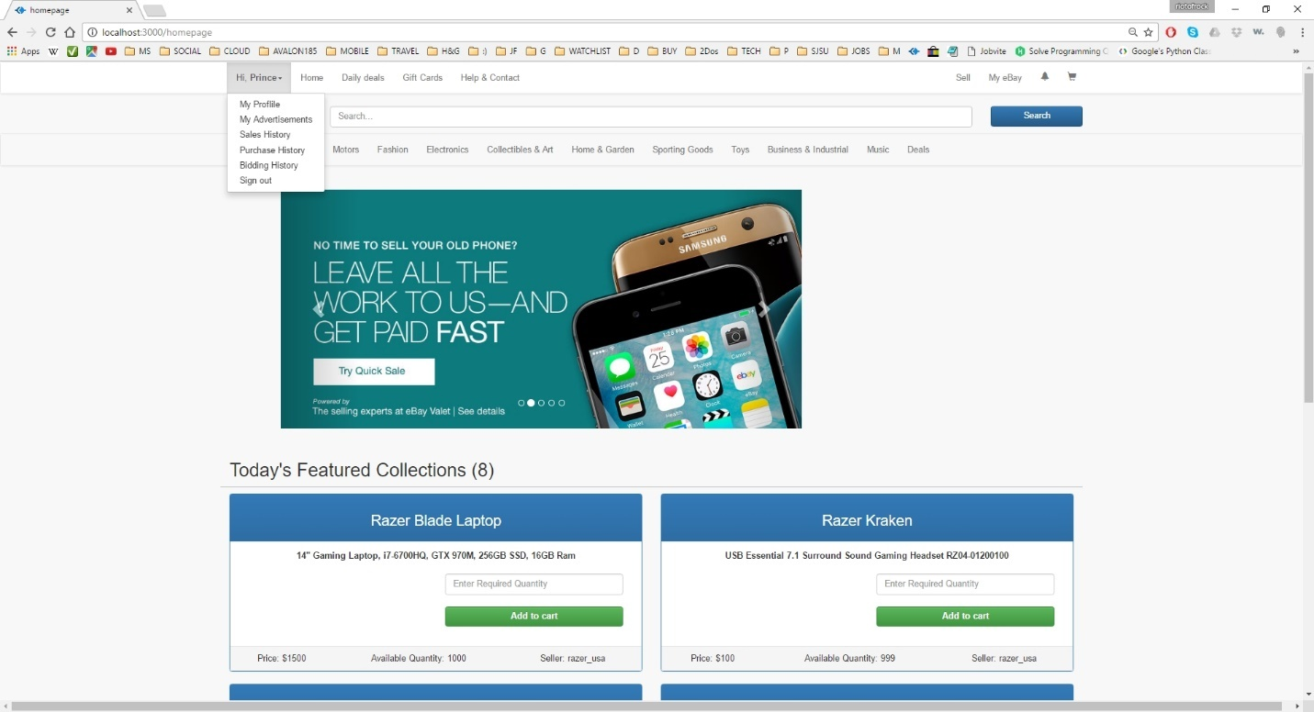

**Image description:** home page – drop down options listed in the main header (functionalities)

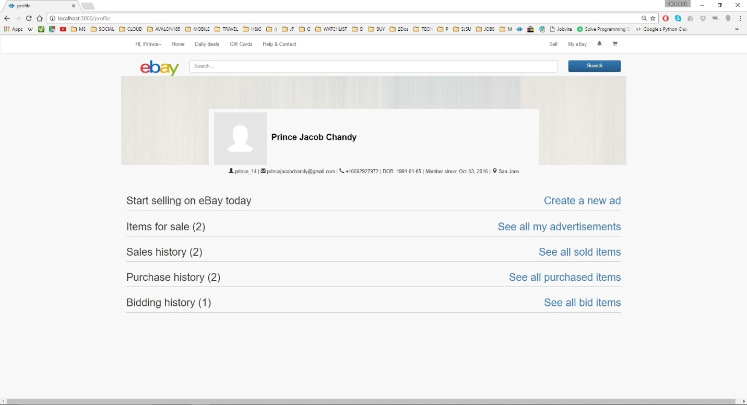

**Image description:** profile page – displays profile information and purchase/sale history; also allows user to create his own advertisements (normal and bid)

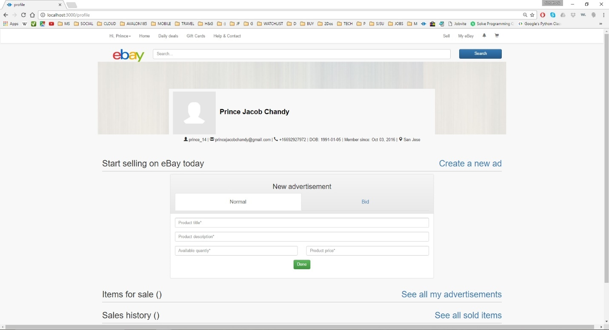

**Image description:** profile page – create a new normal advertisement (1) - required fields are marked by * and an ad can be created only if all the required information is filled

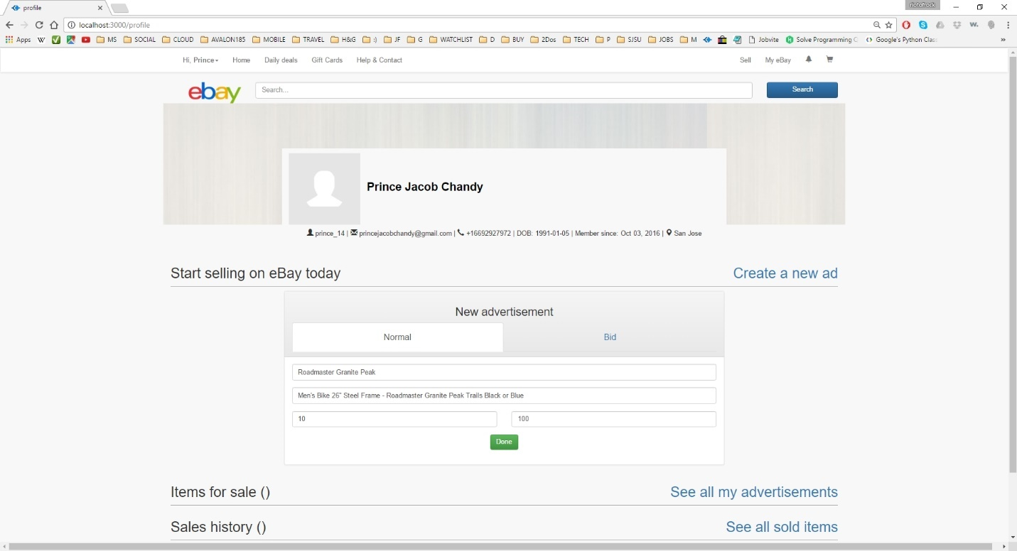

**Image description:** profile page – create a new normal advertisement (2)

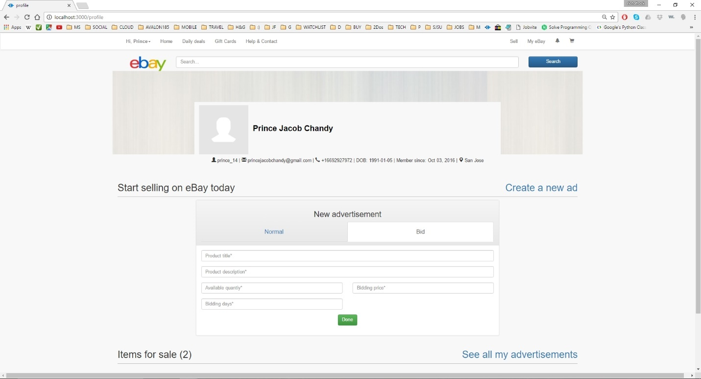

**Image description:** profile page – create a new bidding advertisement (1) - required fields are marked by * and an ad can be created only if all the required information is filled

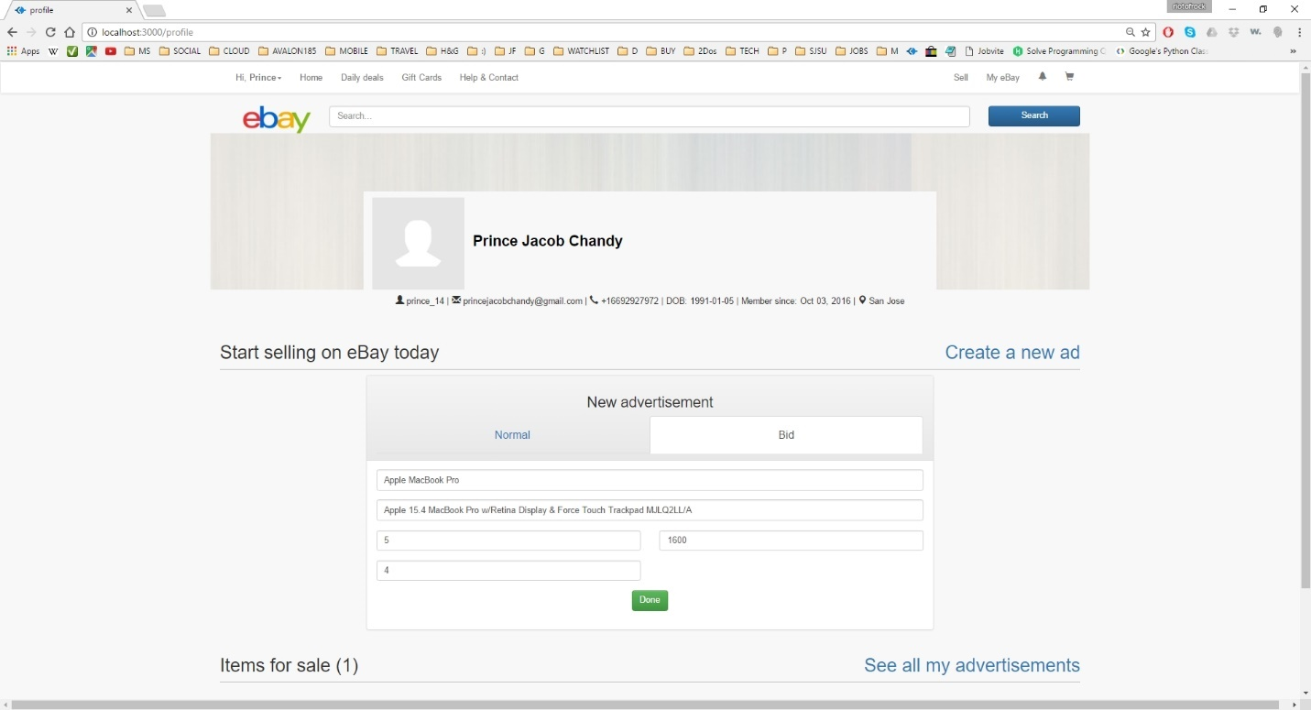

**Image description:** profile page – create a new bidding advertisement (2)

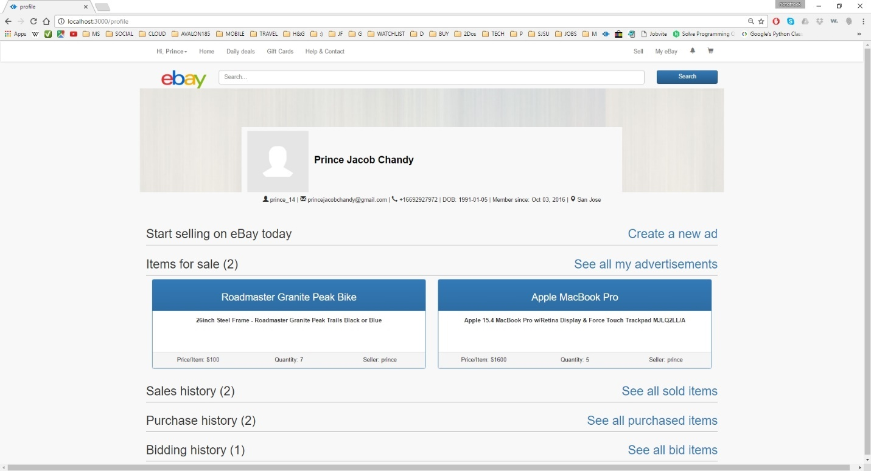

**Image description:** profile page – see all advertisements created by the user

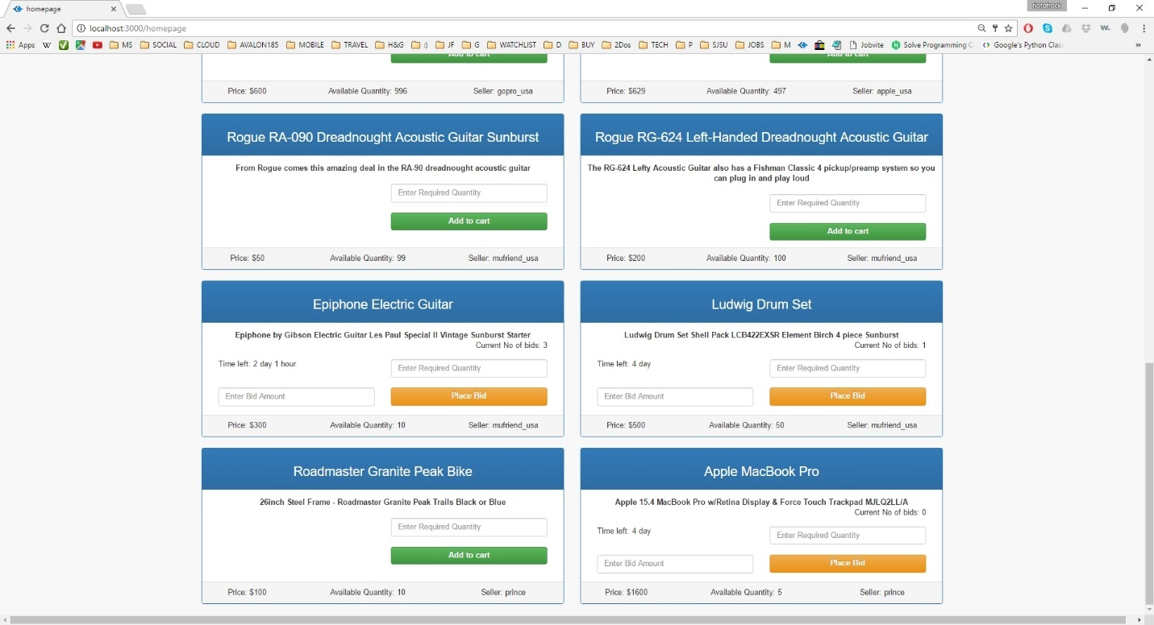

**Image description:** home page – newly created advertisements created as seen in another user’s homepage

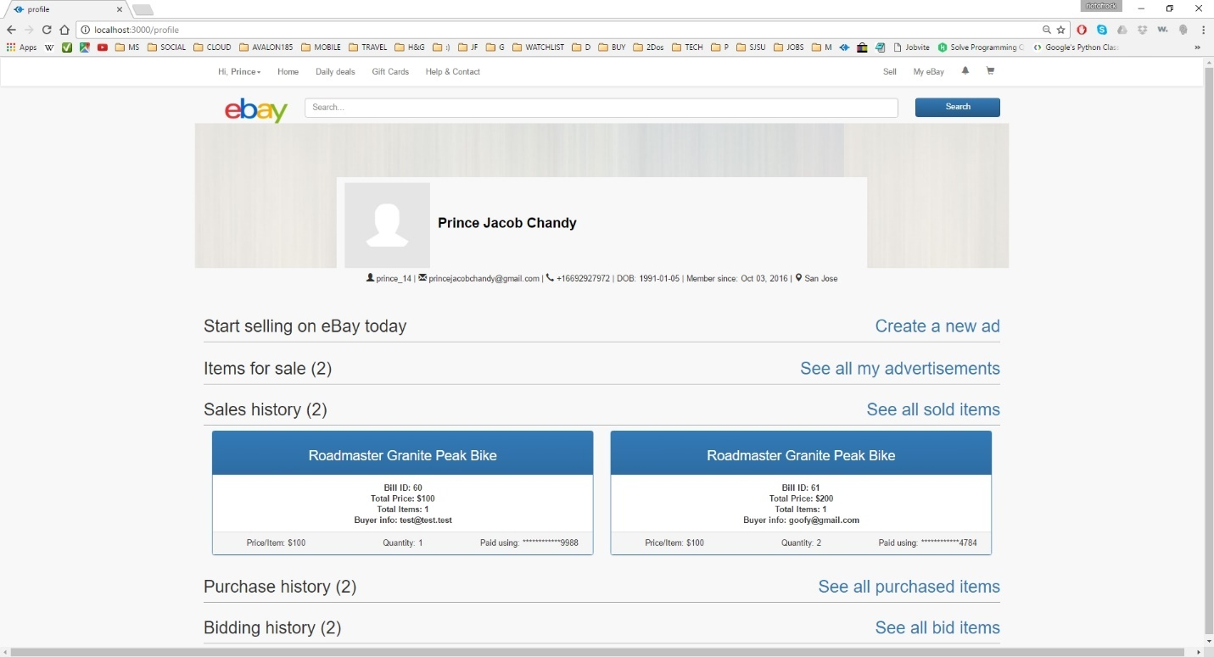

**Image description:** profile page – sales history of current user’s products with buyer details and billing information

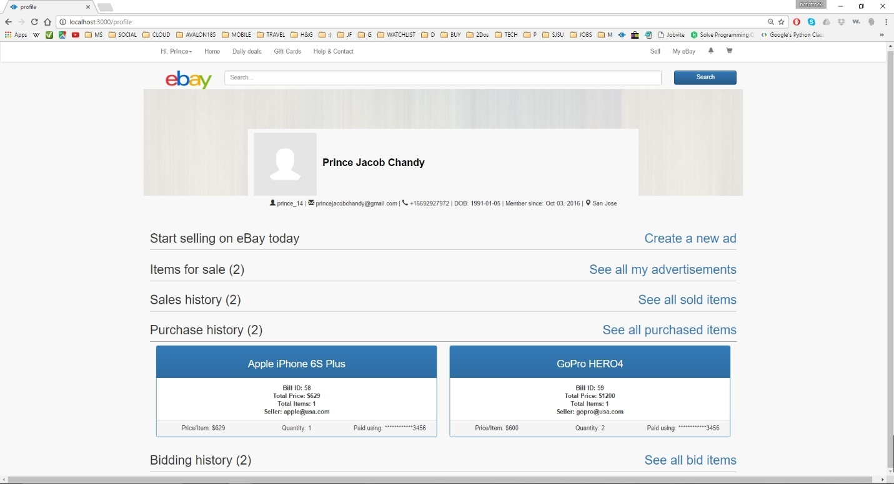

**Image description:** profile page – purchase history of current user with seller details and billing information

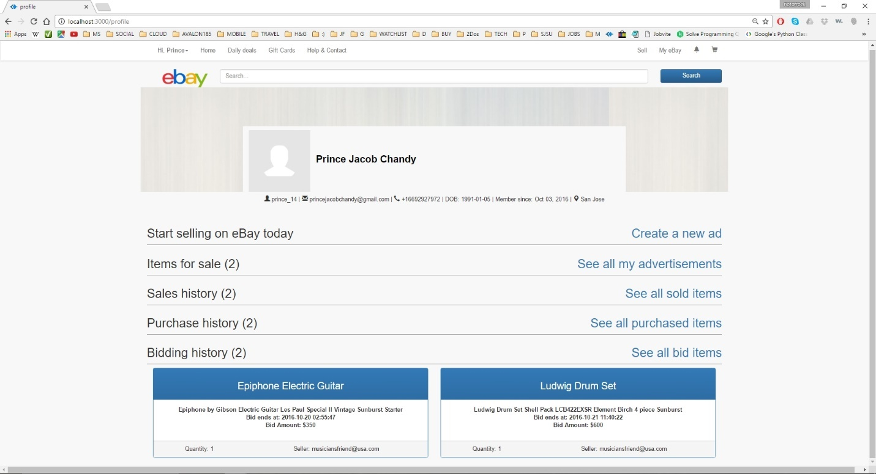

**Image description:** profile page – bidding history of current user with seller details and bidding information; list all the products bid by the user which is active

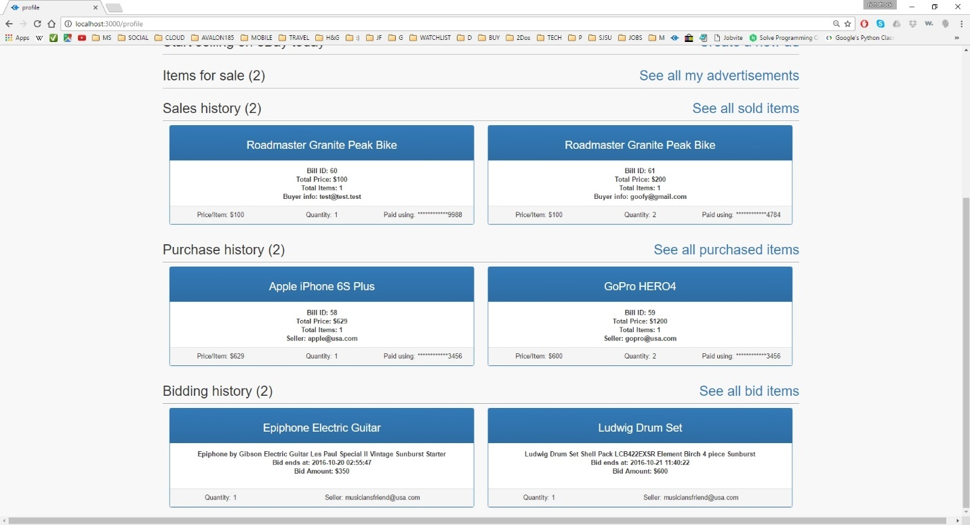

**Image description:** profile page – sales history, purchase history, bidding history

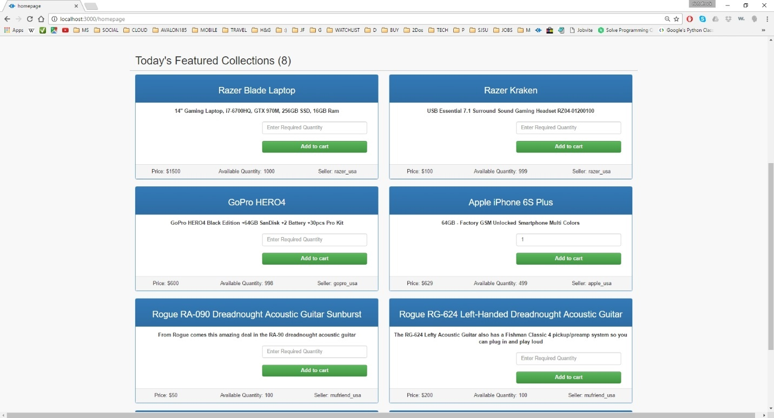

**Image description:** home page – buying a normal product by entering required quantity and clicking add to cart; add to cart button will proceed to cart only if the entered quantity is less than available quantity

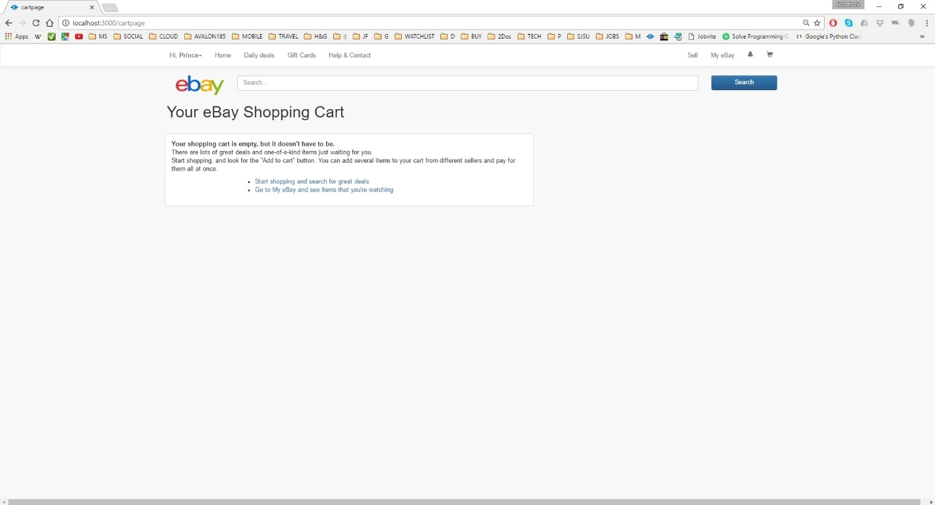

**Image description:** shopping cart page – when empty; Items in shopping cart when added will be added to session as well as database so that user gets his shopping cart information when he returns later after logout

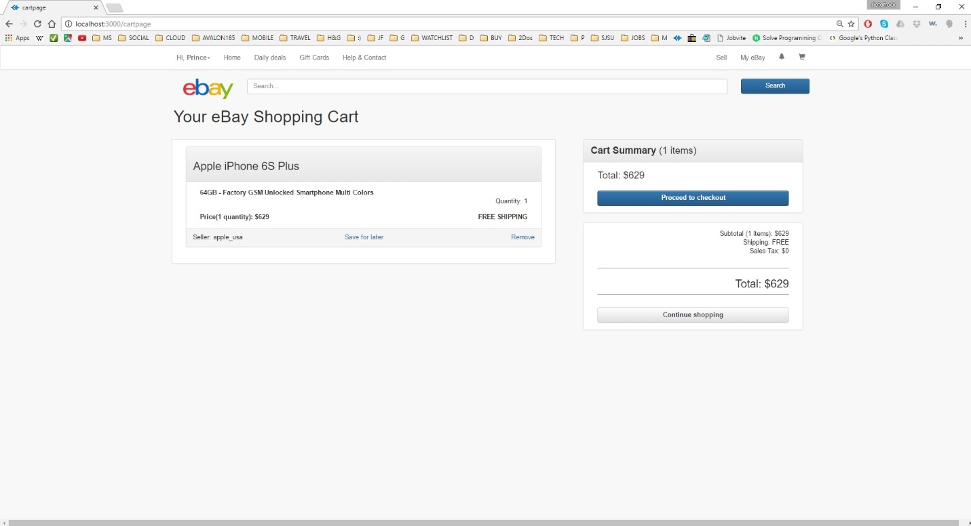

**Image description:** shopping cart page - all the items added by the user from homepage is listed here. Pressing add to cart from home page routes to shopping cart page. Can access this page also by clicking at the cart icon at the extreme top left

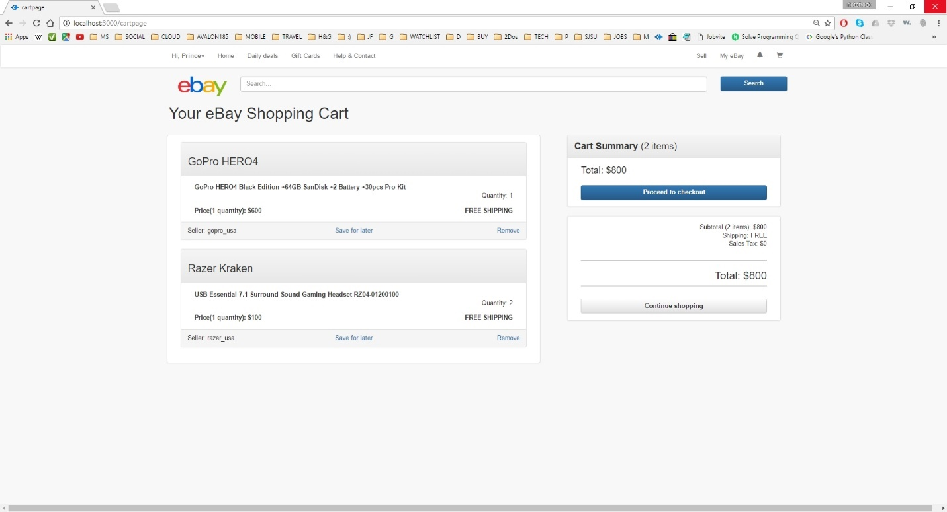

**Image description:** shopping cart page – with multiple items and total amount, items details; Note that delete option is provided for all items to remove them from the cart. Continue shopping routes back to the homepage

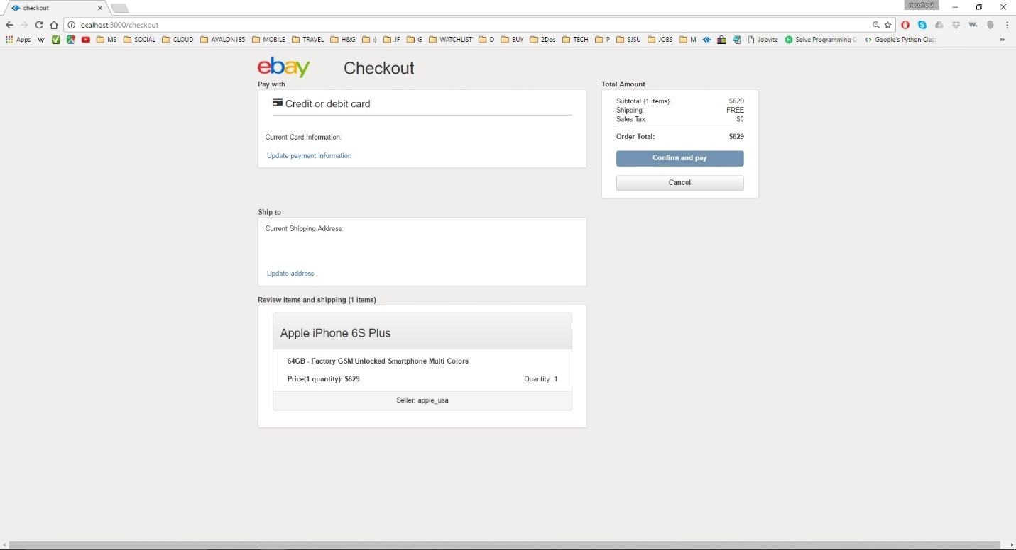

**Image description:** checkout page – user can provide (add/update) payment information and shipping address information. Confirm and pay button will be active only after entering valid creditcard information and shipping address

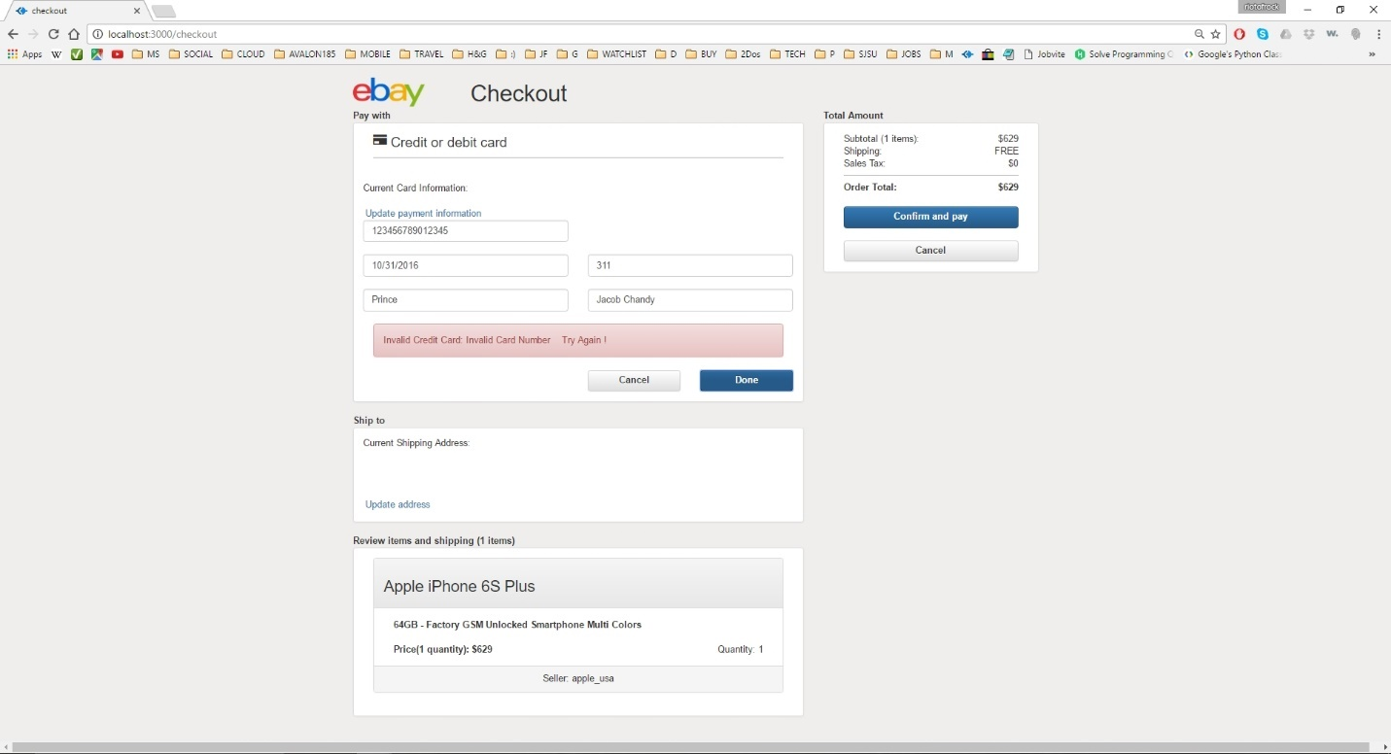

**Image description:** checkout page – payment/credit card validation (1)

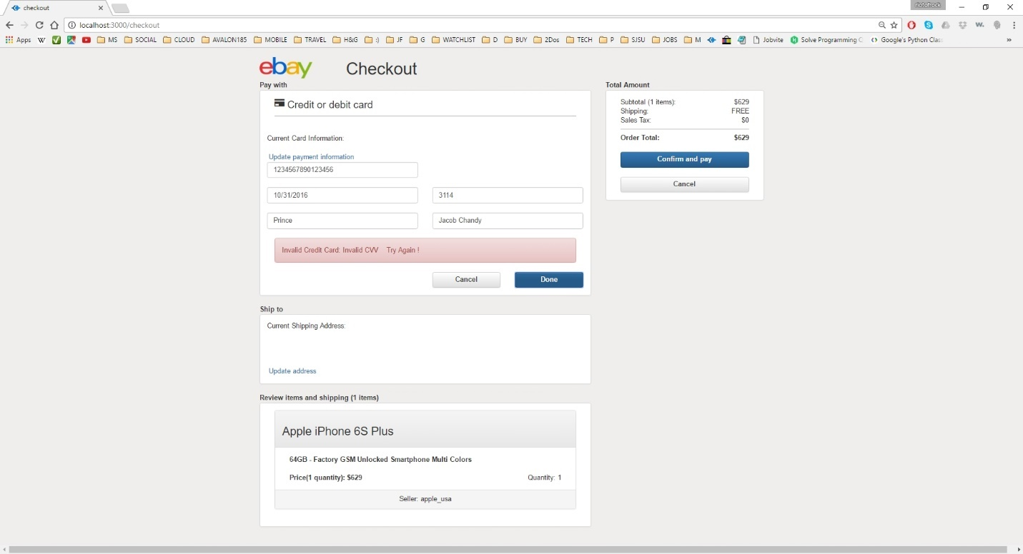

**Image description:** checkout page – payment/credit card validation (2)

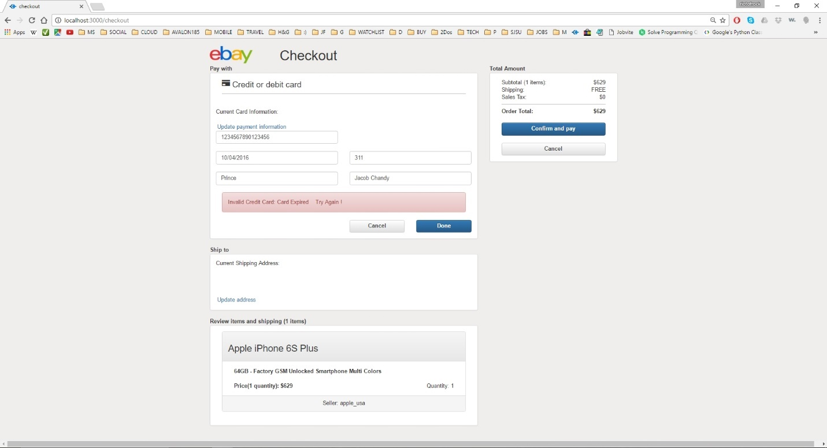

**Image description:** checkout page – payment/credit card validation (3)

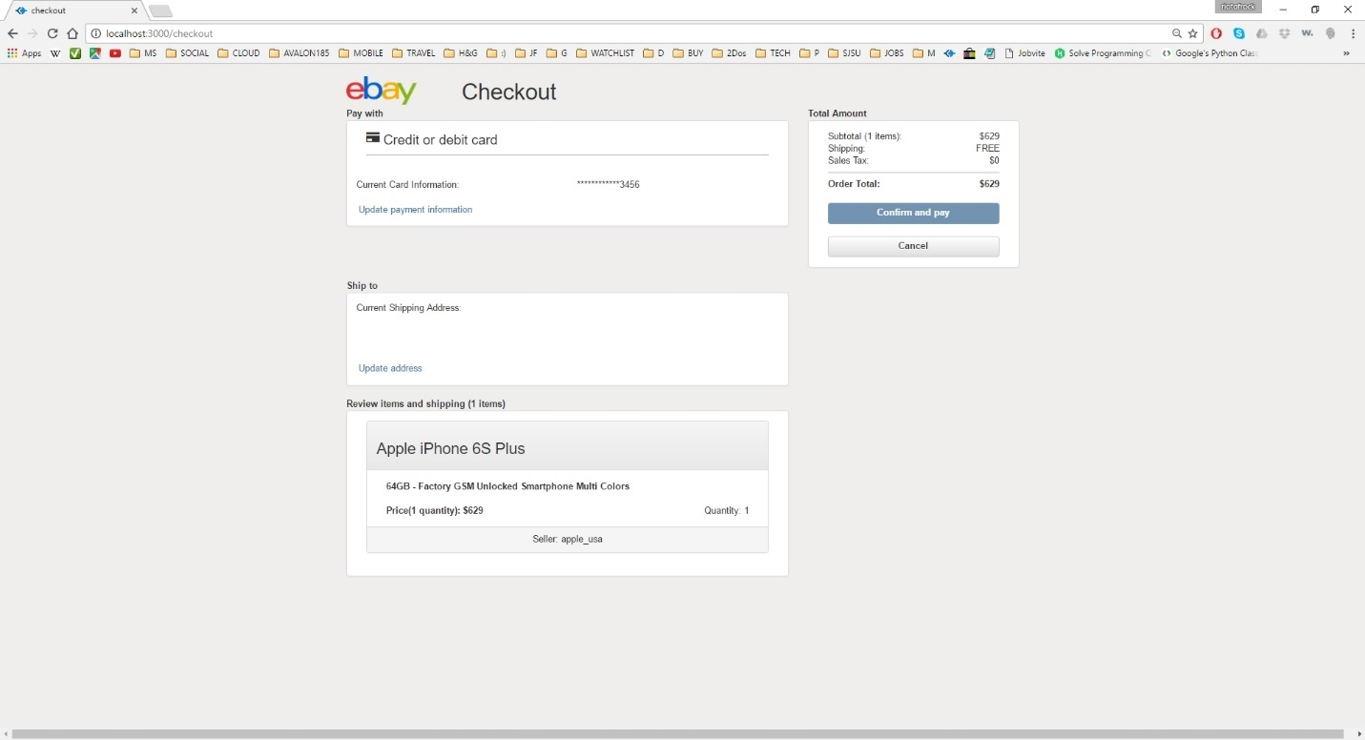

**Image description:** checkout page – payment/credit card validation success and information have been updated in database

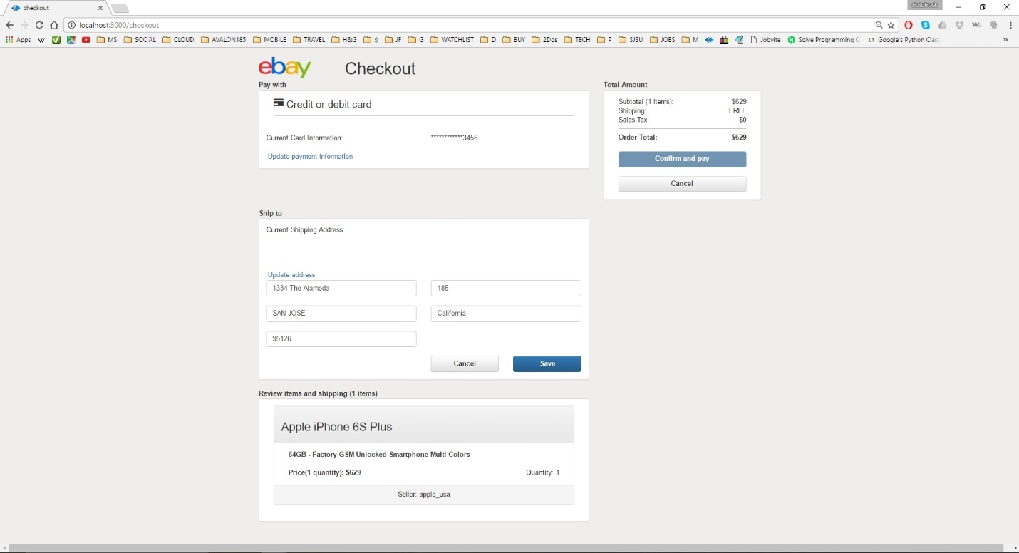

**Image description:** checkout page – shipping address addition/update

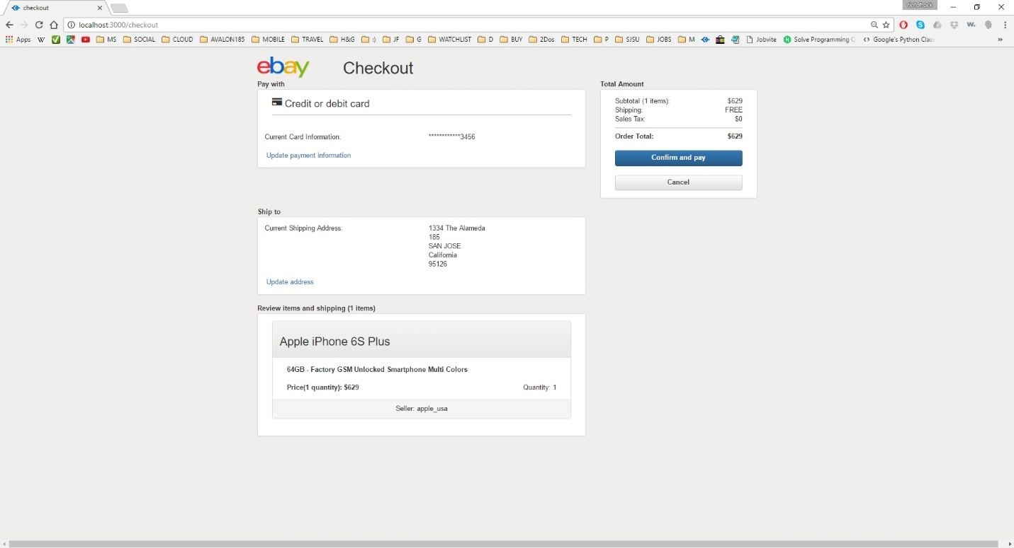

**Image description:** checkout page – confirm and pay button active since now we have valid payment and shipping information; checkout checks one final time in the database where the product and quantity in the cart is available and proceed to successful checkout page if available, or else to fail checkout page

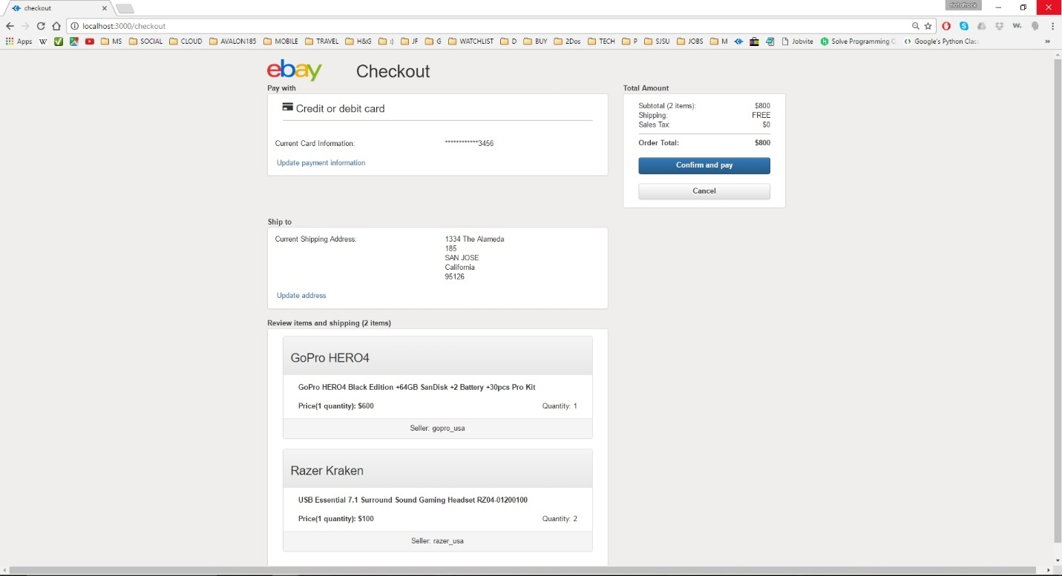

**Image description:** checkout page with multiple items in cart

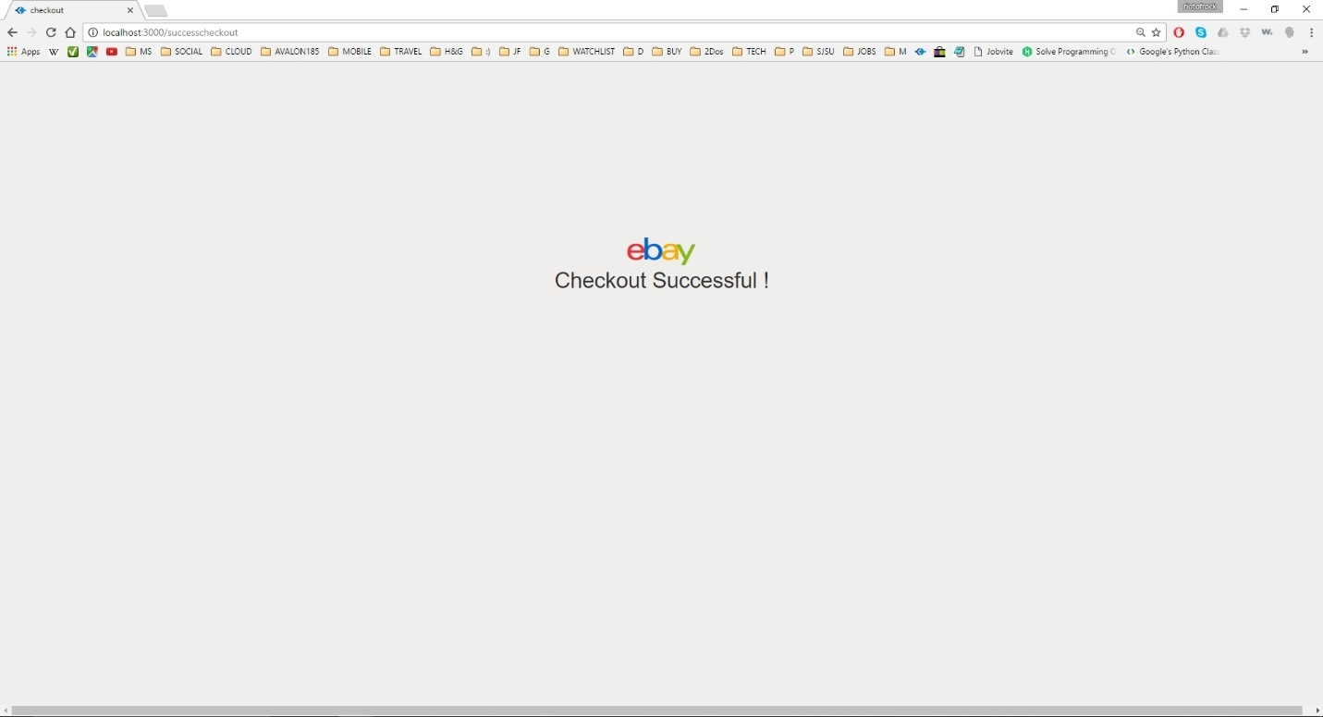

**Image description:** checkout successful page; can return back to main page by clicking on ebay image

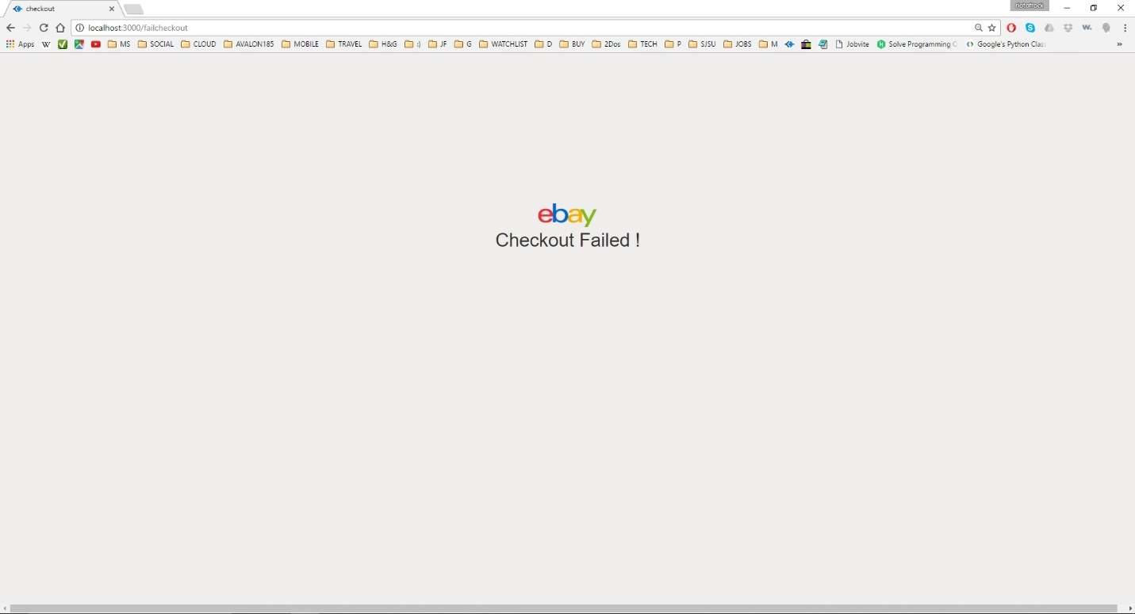

**Image description:** checkout failure page; can return back to main page by clicking on ebay image

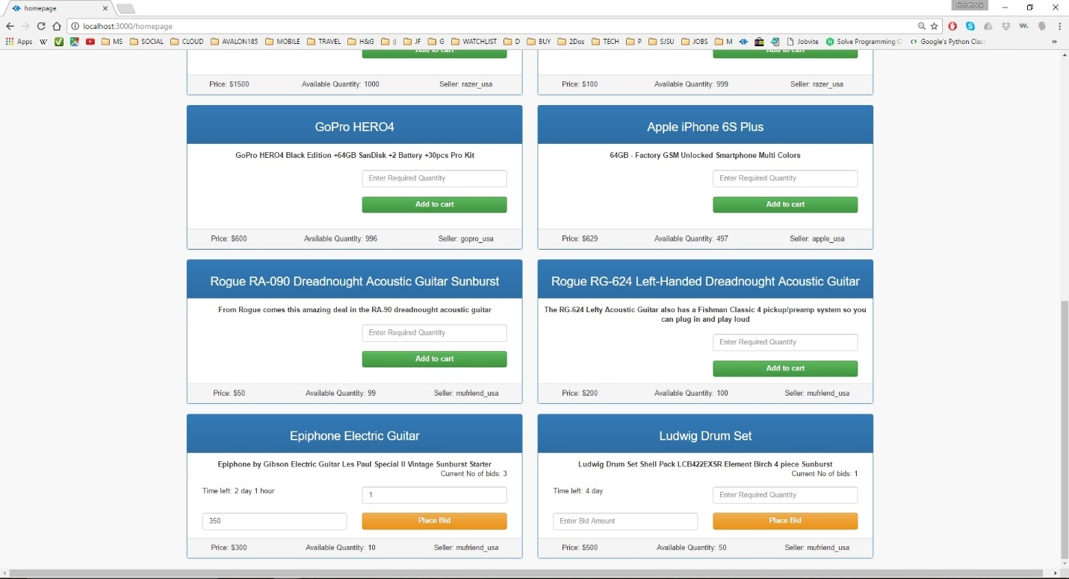

**Image description:** home page – bidding an item; user can bid an item by entering bid amount and the required quantity. Bidding will be allowed if the required quantity is more than the available quantity and the bid amount is more than the current product price displayed. Bid products display the current number of bids made on the product as well as the time left for bidding.

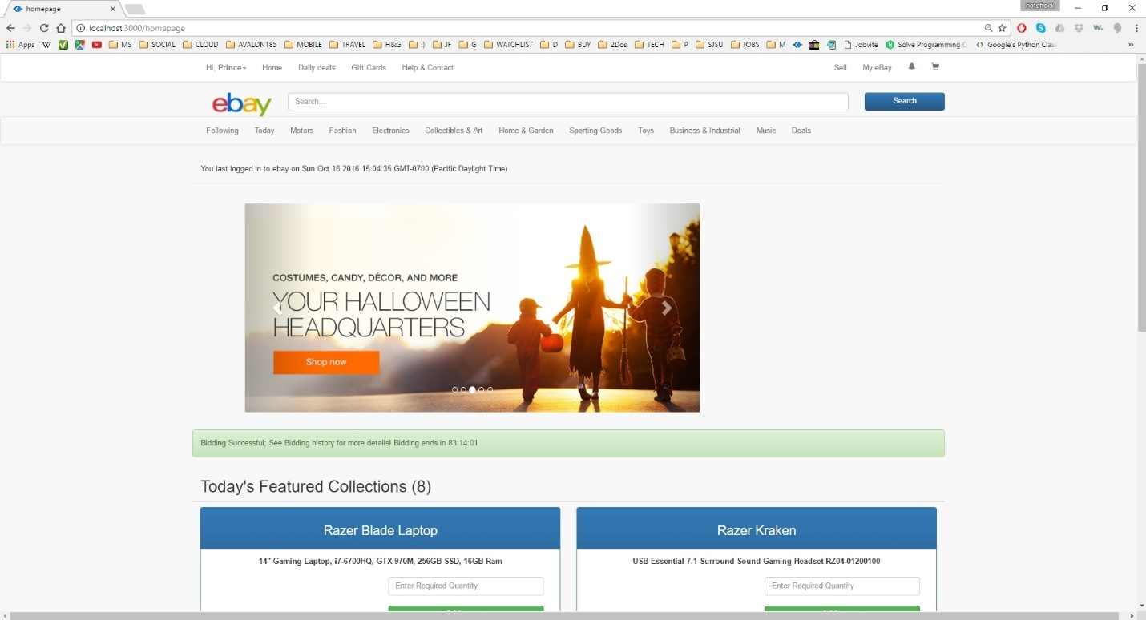

**Image description:** home page – bidding successful prompt will be shown to the user with the bidding timer information (time left till the bidding ends)

**IV. PERFORMANCE GRAPHS & ANALYSIS**

Part 1 – Calculator

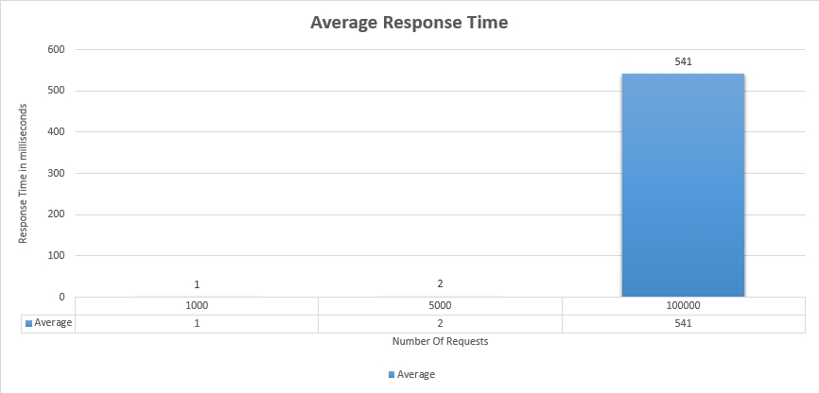

**Image description:** Number of concurrent users versus average response time in milliseconds for random operations

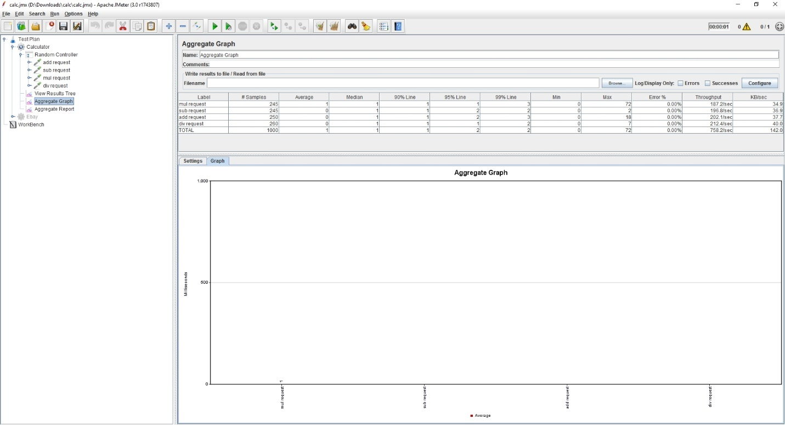

**Image description:** Number of concurrent users versus average response time in milliseconds for random operations – for 1000 users

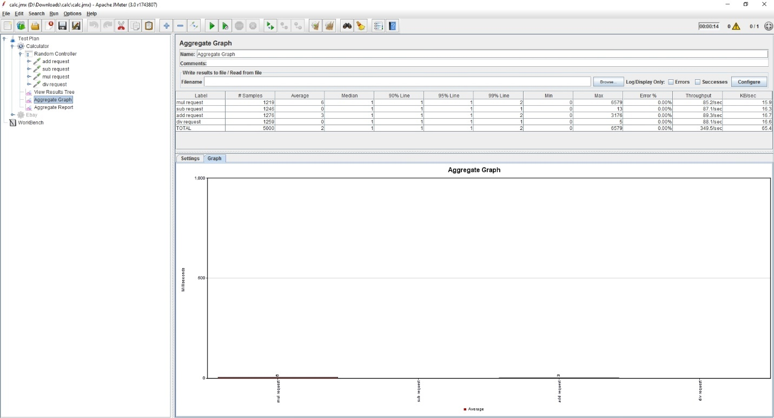

**Image description:** Number of concurrent users versus average response time in milliseconds for random operations – for 5000 users

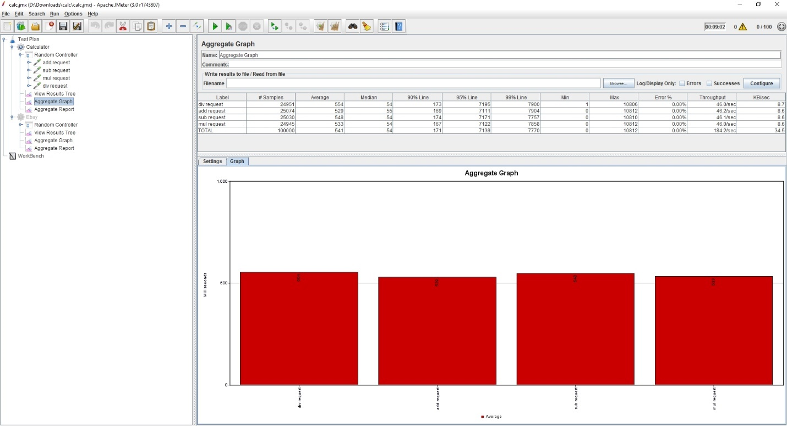

**Image description:** Number of concurrent users versus average response time in milliseconds for random operations – for 100000 users

Analysis:

The implementation was done in a random controller with 4 (addition, subtraction, deletion, multiplication) requests/operations placed in the controller.

Average response time for 1000 users was found to be 1, 2 for 5000 users and 541 for 100000 users. Response time is found to be increase as the number of users or number of requests hitting the server increases.

Part 2 – eBay Application

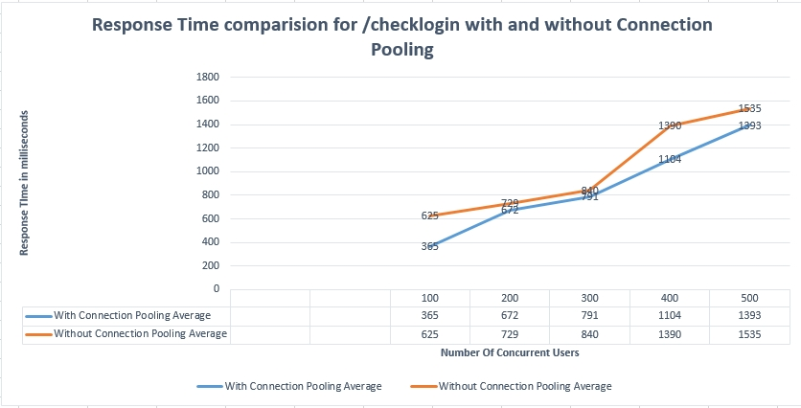

**Image description:** Comparison - number of concurrent users versus average response time in milliseconds for sign- in operation with and without using connection pool

Analysis:

Response time offered with connection pooling implies better performance than the one offered without connection pooling for all the 5 test scenarios (100, 200, 300, 400, 500 users). Connection pooling improves response time, as the time associated with creation and deletion of connections are avoided.

**Testing Using mocha framework:**

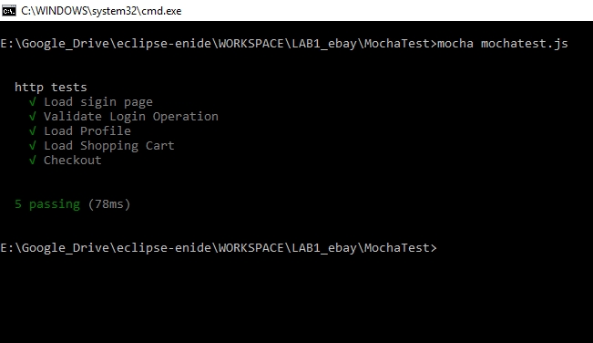

**Functions tested as part of Mocha Unit Testing**

it('Load sigin page', **function**(done){

http.get('http://localhost:3000/', **function**(res) {

assert.equal(200, res.statusCode);

done();

});

});

it('Validate Login Operation', **function**(done) {

request.post(

'http://localhost:3000/checklogin',

{ form: { username: "test@test.test", signpassword: "pmanga" } },

**function** (error, response, body) {

assert.equal(200, response.statusCode);

done();

}

);

});

it('Load Profile', **function**(done) {

request.get(

'http://localhost:3000/profile',

**function** (error, response, body) {

assert.equal(200, response.statusCode);

done();

}

);

});

it('Load Shopping Cart', **function**(done) {

request.get(

'http://localhost:3000/cartpage',

**function** (error, response, body) {

assert.equal(200, response.statusCode);

done();

}

);

});

it('Checkout', **function**(done) {

request.get(

'http://localhost:3000/checkout',

**function** (error, response, body) {

assert.equal(200, response.statusCode);

done();

}

);

});

**Part 3 – Question & Answers**

**Question 1**. Explain the encryption algorithm used in your application. Mention different encryption algorithms available and the reason for your selection of the algorithm used

The encryption algorithm used in the application is AES.

Other available encryption algorithms are: MD5, Triple DES, RSA, Blowfish, Twofish

Why AES?

* AES is more secure (it is less susceptible to cryptanalysis than 3DES)
* AES supports larger key sizes than 3DES's 112 or 168 bits
* AES is faster in both hardware and software
* AES's 128-bit block size makes it less open to attacks via the [birthday problem](https://en.wikipedia.org/wiki/Birthday_problem) than 3DES with its 64-bit block size.
* AES is required by the latest U.S. and international standards

**Question 2.** Compare the Results of the graphs with and without connection pooling. Explain the results in detail. Describe the algorithm of connection pooling used in your application.



**Image description:** Comparison - number of concurrent users versus average response time in milliseconds for sign- in operation with and without using connection pool

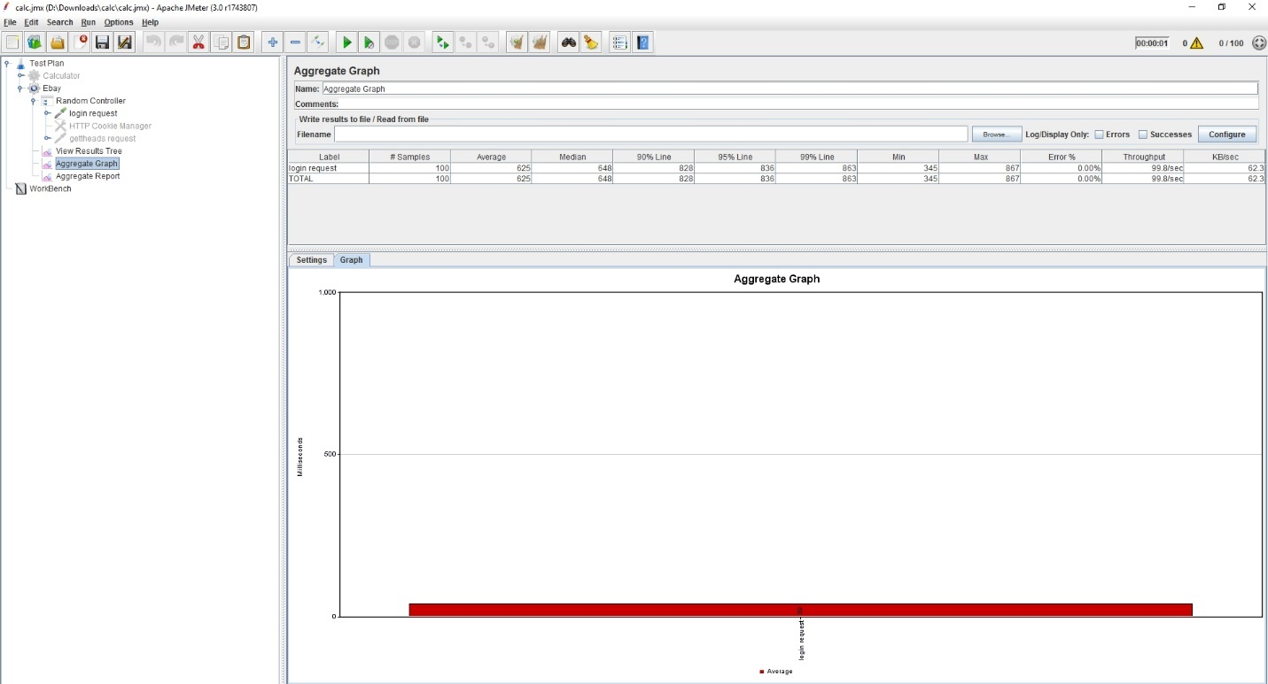

**Image description:** Number of concurrent users versus average response time in milliseconds, without connection pooling – for 100 users

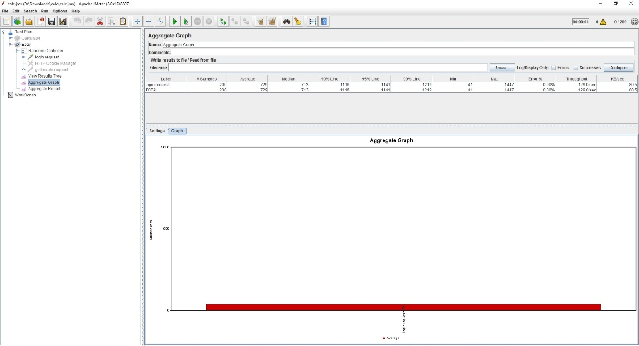

**Image description:** Number of concurrent users versus average response time in milliseconds, without connection pooling – for 200 users

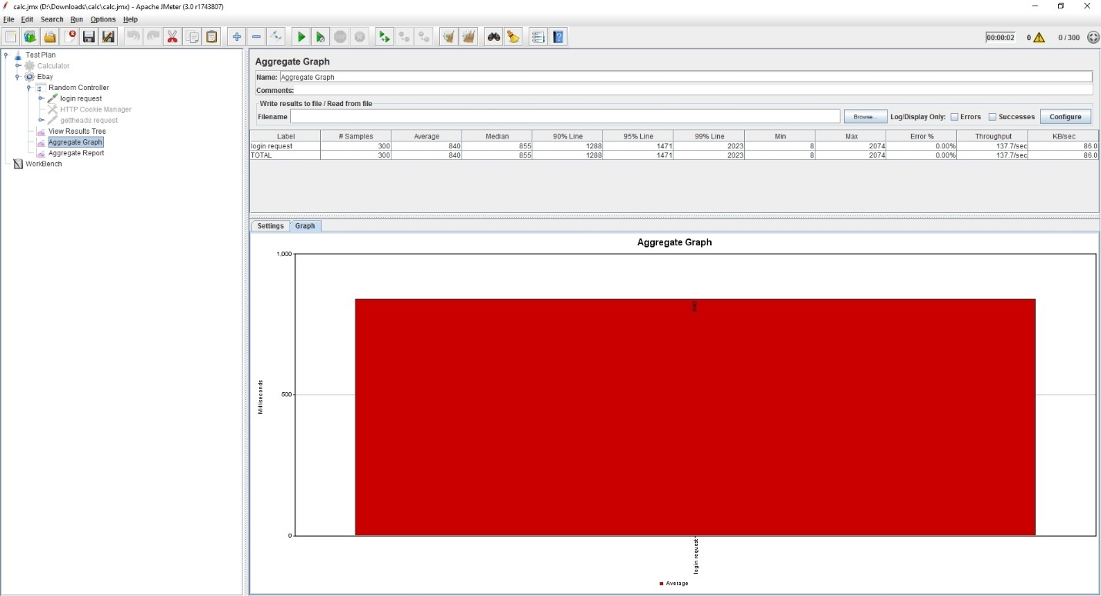

**Image description:** Number of concurrent users versus average response time in milliseconds, without connection pooling – for 300 users

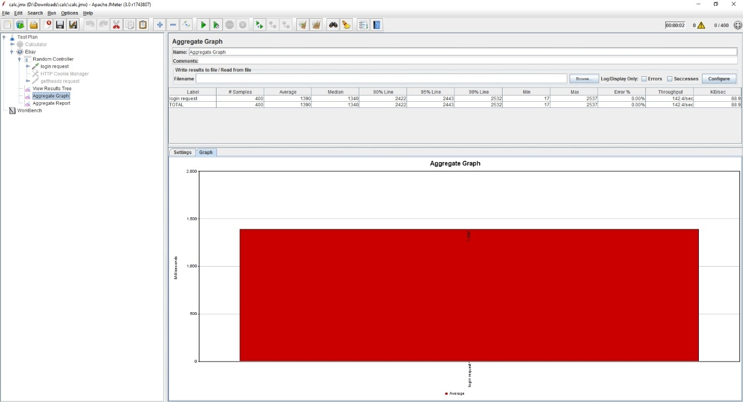

**Image description:** Number of concurrent users versus average response time in milliseconds, without connection pooling – for 400 users

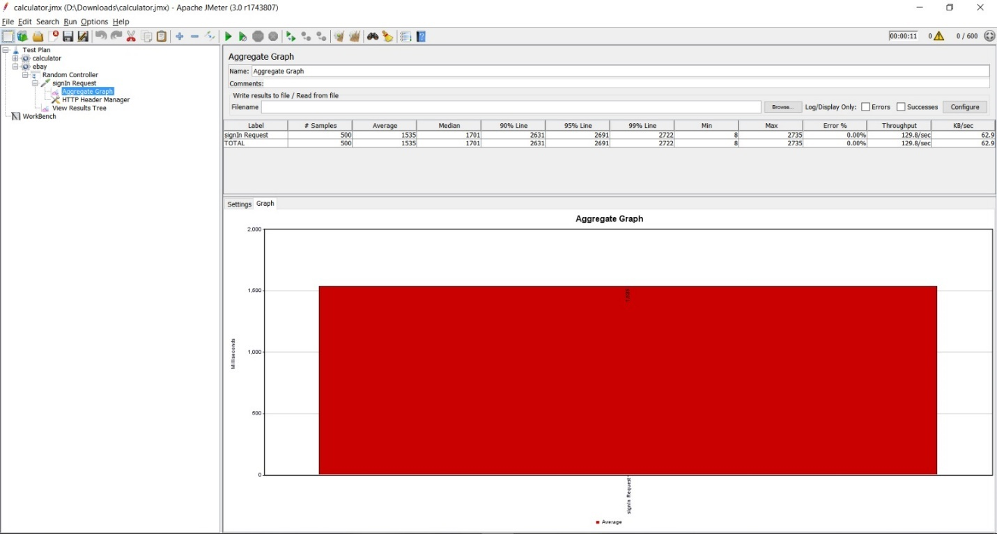

**Image description:** Number of concurrent users versus average response time in milliseconds, without connection pooling – for 500 users

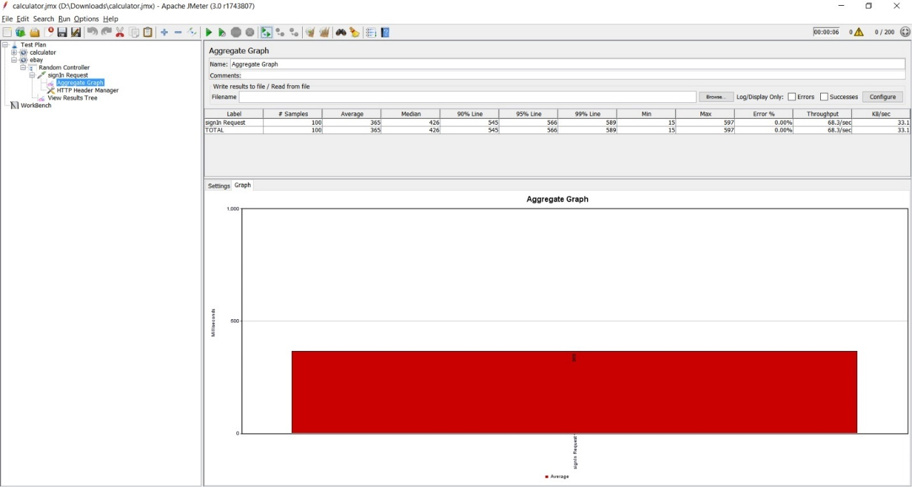

**Image description:** Number of concurrent users versus average response time in milliseconds, with connection pooling – for 100 users

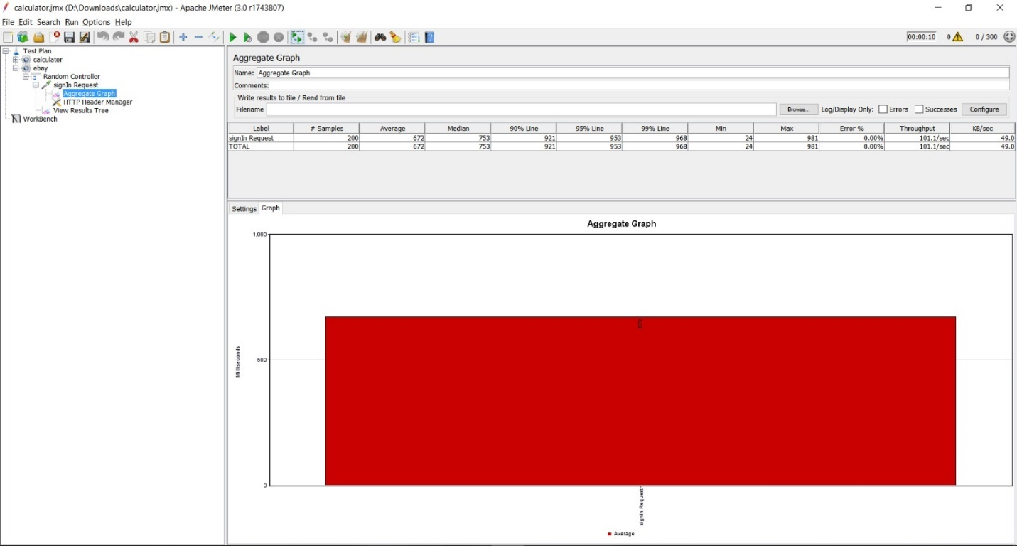

**Image description:** Number of concurrent users versus average response time in milliseconds, with connection pooling – for 200 users

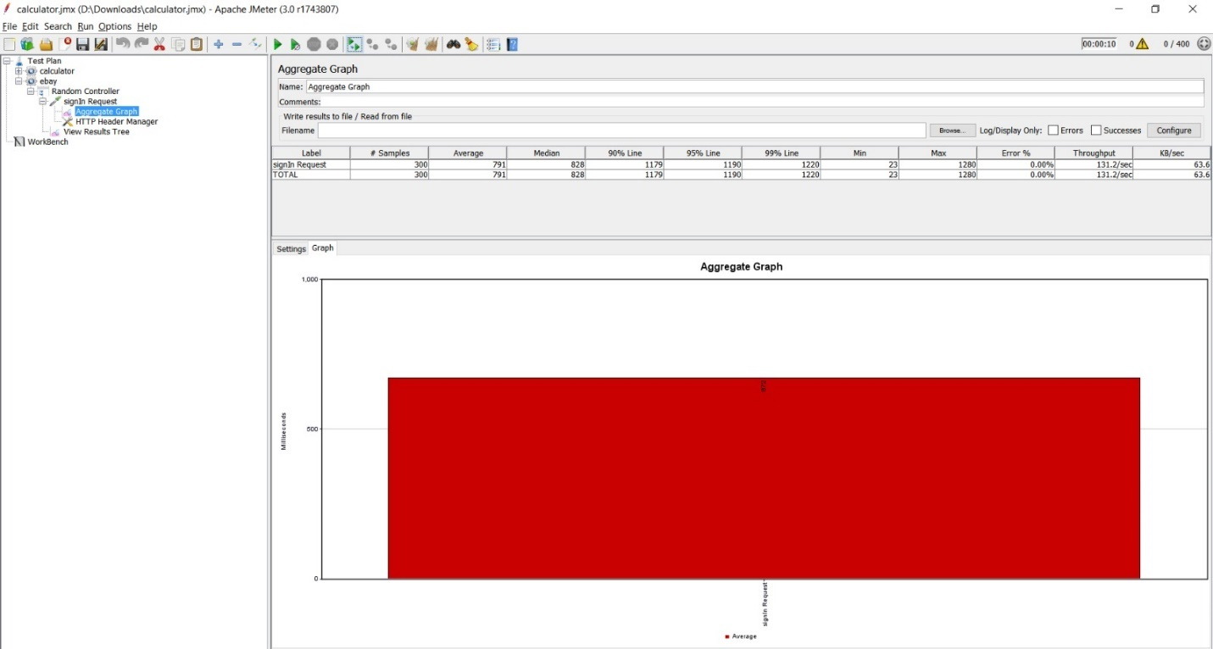

**Image description:** Number of concurrent users versus average response time in milliseconds, with connection pooling – for 300 users

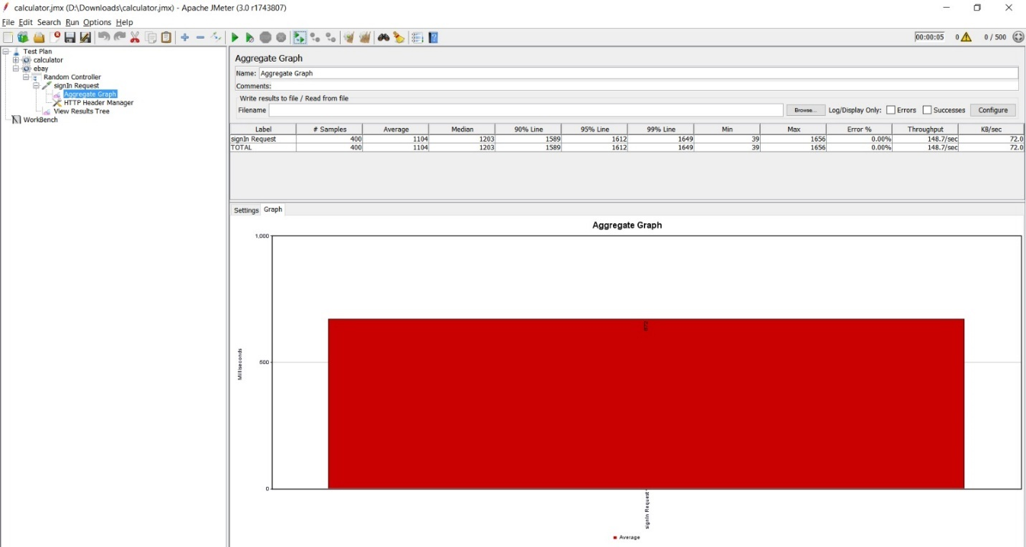

**Image description:** Number of concurrent users versus average response time in milliseconds, with connection pooling – for 400 users

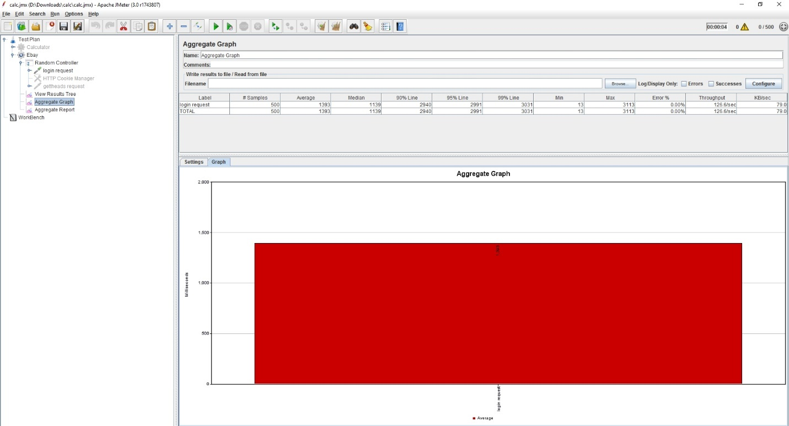

**Image description:** Number of concurrent users versus average response time in milliseconds, with connection pooling – for 500 users

Analysis:

Response time offered with connection pooling implies better performance than the one offered without connection pooling for all the 5 test scenarios (100, 200, 300, 400, 500 users). Connection pooling improves response time, as the time associated with creation and deletion of connections are avoided.

Algorithm:

1) Pool creates connections with a limit

2) Connections are then cycled round-robin style, with connections being taken from the top of the pool and returning to the bottom

3) When a previous connection is retrieved from the pool, a ping packet is sent to the server to check if the connection is still good

4) When you are done with a connection, call connection.release() and the connection will return to the pool, ready to be used again by someone else

5) Close the connection and remove it from the pool, using connection.destroy() . The pool will create a new connection the next time one is needed

**Question 3.** How would you implement Request Caching? Explain in detail. No need to implement a function – use pseudo code or detailed explanation

Caching mechanisms enable web services/applications to run faster. Appropriate use of these standards can benefit the web application and can improve response time and will reduce server loads.

Redis, HTTP Caching, Internal Node JS Caching, Mem Cache etc.. are examples for caching mechanisms

HTTP caching is a universally adopted specification across all modern web browsers, making its implementation in web applications simple. As the browser stores local copies of the sever resources, faster retrieval leads to better performance times. We can implement caching by specifying the ‘cache-control’ attribute in the header. By modifying the header values, we can implement the caching, also the amount of time the resource can be cached can also be specified.

Redis can be used to provide a better implementation.

1) Install redis module

2) Inject the dependency using require

3) Set the environment variable

4) Check the Redis cache whether we have a respective response for an incoming request

5) Store the compiled data to Redis